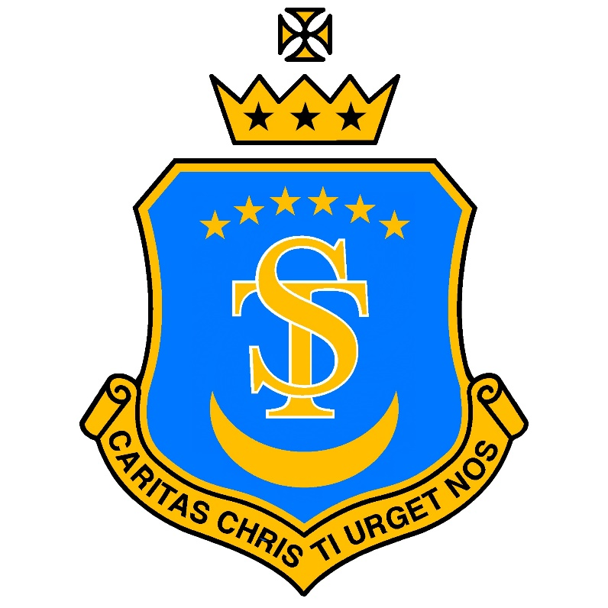

St Teresa’s Catholic Primary School
“With Jesus we live, love and learn”

Whole-School Allergy and Special Diets Policy
Date policy last reviewed: | Sep 2026
Last updated: September 2026
Signed by:
 | Headteacher | Date:
 | Chair of governors | Date:

1. Introduction
St Teresa’s Catholic Primary School is committed to providing a safe, inclusive environment for pupils with allergies, intolerances and other medically required special diets.
Food allergies can cause serious and potentially life-threatening reactions. The school therefore takes a whole-school approach to allergy safety, involving school leaders, teaching and support staff, lunchtime staff, catering staff, pupils and parents/carers.
This policy has been developed with regard to:
- the Children and Families Act 2014;
- the statutory guidance Supporting Pupils at School with Medical Conditions;
- the Department for Education statutory guidance Allergy Safety in Schools;
- national reforms to allergy safety in schools introduced from September 2026, commonly associated with the Benedict Blythe campaign;
- Department of Health guidance concerning the use of adrenaline auto-injectors (AAIs) in schools; and
- guidance provided by the Essex School Meals Advisory Service.
The school recognises that it cannot guarantee an entirely allergen-free environment. Our approach is therefore based upon awareness, accurate information, appropriate controls, clear communication and effective emergency preparedness, rather than relying solely upon blanket bans.
2. Aims
This policy aims to:
- protect pupils with known allergies and reduce the risk of accidental exposure;
- ensure allergies and medically required special diets are accurately identified and recorded;
- ensure relevant staff have the information they need to support individual pupils safely;
- ensure pupils with allergies are clearly identified during school meal service;
- establish safe arrangements for food preparation and service;
- ensure staff can recognise the signs of an allergic reaction and anaphylaxis;
- ensure appropriate emergency medication is readily accessible;
- ensure staff are trained and confident in responding to anaphylaxis and administering adrenaline;
- support pupils with allergies to participate fully in school life;
- ensure effective communication between parents/carers, school staff and catering staff; and
- learn from any allergic reaction, incident or near miss.
3. Understanding Allergies
Food allergy
A food allergy occurs when the immune system reacts to a particular food or substance. Reactions may occur very quickly and can range from relatively mild symptoms to a severe, life-threatening reaction.
Symptoms may include:
- itching or tingling;
- hives or a raised rash;
- swelling of the face, lips or eyes;
- nausea, vomiting or abdominal pain;
- swelling of the tongue or throat;
- difficulty swallowing or speaking;
- wheezing or difficulty breathing;
- dizziness, confusion or collapse.
Anaphylaxis
Anaphylaxis is a severe allergic reaction requiring immediate emergency action.
Staff are trained to recognise serious ABC symptoms affecting:
- Airway – swelling of the throat or tongue, difficulty swallowing or a hoarse voice;
- Breathing – difficulty breathing, wheezing, noisy breathing or persistent coughing;
- Circulation – dizziness, faintness, confusion, pale or clammy appearance, collapse or loss of consciousness.
Adrenaline is the first-line emergency treatment for anaphylaxis.
Food intolerance
A food intolerance does not involve the immune system in the same way as an allergy and is not normally life-threatening. Symptoms can nevertheless cause significant discomfort and must be managed appropriately.
The school will ensure that staff understand the distinction between an allergy, which may present an immediate risk to life, and an intolerance.
Coeliac disease
Coeliac disease is an autoimmune condition triggered by gluten. Pupils diagnosed with coeliac disease require a gluten-free diet and will be supported in accordance with medical advice.
4. Identification and Recording of Allergies
Parents/carers must inform the school of any known allergy, intolerance or medically required special diet when their child joins the school or as soon as a condition is diagnosed.
Information will be recorded on the school's medical records and made available to staff who need it in order to keep the pupil safe.
Where appropriate, the school will establish an Individual Healthcare Plan (IHP) in consultation with parents/carers and relevant healthcare professionals.
An IHP may include:
- the pupil's known allergens and triggers;
- signs and symptoms specific to the pupil;
- actions to take in the event of a reaction;
- prescribed medication;
- arrangements for storing and accessing medication;
- arrangements for educational visits and extracurricular activities;
- emergency contact information; and
- consent and arrangements relating to emergency adrenaline.
Information will be reviewed when circumstances change and at appropriate intervals.
Photographs and allergy information may be shared with relevant school and catering staff where this is necessary to protect the pupil.
5. Allergy Identification at Lunchtime
St Teresa’s operates an additional identification system for pupils with known food allergies during school meal service.
Children with identified food allergies wear a clearly visible allergy lanyard at lunchtime. The lanyard identifies the child's allergy so that catering and lunchtime staff can immediately recognise that the child requires additional checks before food is served.
Staff ensure that the appropriate lanyard is worn before the pupil reaches the point of meal service.
The lanyard system provides an important additional layer of protection but does not replace:
- the school's allergy register;
- information held by the catering team (displayed in the kitchen);
- the pupil's Individual Healthcare Plan;
- appropriate communication between school and catering staff; or
- normal allergen checking and food safety procedures.
Staff must never assume that a meal is safe solely because a pupil is wearing a particular lanyard. The normal catering and allergen-control procedures must always be followed.
Pupils will be supported to understand that the lanyard is a safety measure and should not be swapped, removed or given to another pupil during meal service.
6. School Meal and Catering Arrangements
The catering team will maintain accurate information regarding pupils with allergies and special dietary requirements.
The catering team is responsible for ensuring that:
- current allergen information is available for menu items;
- ingredient and supplier information is checked;
- relevant staff are aware of pupils requiring special diets;
- changes to ingredients or substitute products are checked before use;
- food prepared for pupils with allergies is protected from cross-contamination;
- appropriate separate or thoroughly cleaned equipment and utensils are used;
- allergen-free ingredients and prepared meals are appropriately stored and identified;
- staff serving food understand which dishes contain allergens; and
- uncertainty about an ingredient or meal is resolved before food is served.
Where there is any doubt about whether a food is safe for a particular pupil, it will not be served until the position has been clarified.
Lunchtime and catering staff will communicate appropriately before food service so that pupils requiring special diets are known and appropriate arrangements are in place.
7. Food Sharing
Pupils are taught that food and drinks must not be shared.
This is particularly important because a food that is safe for one child may be dangerous to another.
Age-appropriate allergy awareness will be promoted so that pupils understand the reasons for these rules without pupils with allergies being made to feel different or excluded.
8. Food Brought Into School
Allergy risks extend beyond school lunches.
Staff must consider allergy safety when food is brought into school for:
- curriculum activities;
- celebrations;
- class events;
- breakfast or after-school provision;
- fundraising events;
- school fairs;
- parties;
- visitors;
- religious or cultural celebrations; and
- other activities involving food or drink.
Relevant allergy information must be considered when planning these activities.
Parents should not assume that food brought into school will be suitable for every pupil.
The school does not claim to be completely allergen-free or nut-free because it cannot guarantee control of every food or trace of food entering the premises. Instead, the school promotes a culture of high allergy awareness and sensible risk reduction.
Where a specific pupil's medical needs require additional restrictions, these will be considered through an individual risk assessment or IHP.
9. Packed Lunches
Parents/carers remain responsible for ensuring that food provided in their child's packed lunch is suitable for their child.
Parents will be asked to support the school's allergy-safety arrangements and to be considerate of pupils with serious allergies when choosing foods to send into school.
Children must not share items from packed lunches.
We are a nut free school and products that contain nuts cannot be brought in as packed lunches or snacks.
10. Emergency Medication and Kitt Medical
St Teresa’s subscribes to Kitt Medical's Anaphylaxis Kitt service as part of the school's emergency preparedness for anaphylaxis.
The school maintains a clearly identifiable and readily accessible Anaphylaxis Kitt containing spare adrenaline auto-injectors (AAIs) for emergency use.
The Kitt Medical subscription supports the school through:
- provision of spare adrenaline auto-injectors;
- monitoring and replacement of medication before expiry;
- replacement following reported emergency use;
- a visible and accessible emergency Anaphylaxis Kitt;
- allergy and anaphylaxis training for staff; and
- systems to support monitoring, checks and incident reporting.
The location of the Anaphylaxis Kitt is clearly communicated to staff and it must remain readily accessible in an emergency.
The school will undertake the required checks of the Kitt and medication and will ensure that any used, expired or otherwise unavailable medication is replaced.
The school's spare AAIs supplement rather than replace medication prescribed to individual pupils.
Where a child has been prescribed adrenaline auto-injectors, parents/carers remain responsible for supplying the school with the required prescribed medication in accordance with the child's healthcare plan.
11. Staff Training
All staff receive allergy awareness and anaphylaxis training appropriate to their role.
As part of the school's subscription to Kitt Medical, staff undertake training covering:
- allergy awareness;
- recognising allergic reactions;
- recognising anaphylaxis;
- the ABC warning signs;
- appropriate emergency action;
- use of adrenaline auto-injectors; and
- use of the school's Anaphylaxis Kitt.
Staff are therefore trained to administer emergency adrenaline using the school's Kitt Medical equipment when required.
Training records are maintained by the school.
New staff receive appropriate information as part of induction and allergy training is refreshed in accordance with school arrangements and current guidance.
Supply staff, volunteers and other adults working with pupils will be given information appropriate to their role, including information about pupils whose allergies may reasonably affect their work.
Staff must understand that in a suspected case of anaphylaxis obtaining help must not delay the administration of adrenaline.
12. Emergency Response to Suspected Anaphylaxis
Anaphylaxis is a medical emergency.
If a pupil displays signs of anaphylaxis, staff will:
- Administer an appropriate adrenaline auto-injector immediately. Adrenaline should not be delayed where anaphylaxis is suspected.
- Call 999 immediately and state clearly that the child is experiencing anaphylaxis.
- Follow the pupil's Individual Healthcare Plan or emergency action plan where one is available.
- Keep the pupil lying down with their legs raised where possible. If breathing is difficult, they may be allowed to sit up carefully. The pupil must not stand, walk or run.
- Record the time at which adrenaline was administered.
- If symptoms have not improved after five minutes, or deteriorate following initial improvement, administer a second appropriate dose where available.
- Ensure a member of staff remains with the pupil.
- Arrange for another member of staff to meet and direct the ambulance crew.
- Contact the pupil's parents/carers.
- Provide paramedics with relevant information, including known allergies, the suspected trigger and details and timings of medication administered.
A pupil who has experienced suspected anaphylaxis must receive emergency medical assessment even if they appear to recover following adrenaline.
13. Educational Visits and Activities Away From School
Pupils with allergies must be able to participate fully in educational visits and extracurricular activities wherever reasonable arrangements can be made.
Allergy risks will form part of visit planning and risk assessment.
The visit leader must ensure that:
- relevant pupil allergy information is known;
- the pupil's prescribed emergency medication accompanies them;
- emergency medication remains readily accessible;
- an appropriately informed member of staff is present;
- food arrangements have been considered in advance;
- emergency procedures and access to emergency services have been considered; and
- relevant external providers are informed where necessary.
A child's emergency medication must not be left behind when the pupil leaves the school site.
14. Breakfast Clubs, After-School Activities and School Events
The principles within this policy apply throughout the period for which the school is responsible for a pupil.
This includes:
- breakfast provision;
- lunchtime;
- after-school clubs;
- sports activities;
- school performances;
- residential and non-residential visits; and
- school-organised events.
Staff supervising these activities must have access to relevant medical information and know how emergency medication can be accessed.
15. Responsibilities of Parents and Carers
Parents/carers are responsible for:
- informing the school of their child's allergy, intolerance or medically required special diet;
- providing accurate and up-to-date information;
- providing appropriate medical evidence where required;
- providing prescribed medication requested by the school;
- ensuring prescribed medication supplied to school is in date;
- replacing medication when required;
- informing the school promptly of any change in diagnosis, treatment or medical advice;
- informing the school if their child experiences an episode of anaphylaxis outside school where this may affect school arrangements;
- participating in the development and review of their child's IHP where appropriate; and
- helping their child develop age-appropriate understanding and independence in managing their allergy.
Parents should contact the school if they are unsure about any aspect of food provision or allergy management.
16. Responsibilities of School Staff
The Headteacher has overall responsibility for ensuring appropriate allergy-safety arrangements are established and maintained.
The Headteacher and Governing Body will ensure that:
- this policy is implemented and reviewed;
- appropriate staff training is undertaken;
- suitable emergency arrangements are maintained;
- allergy management is considered within wider safeguarding and health and safety arrangements; and
- significant incidents are appropriately reviewed.
Office staff will maintain relevant pupil information and communicate changes to appropriate staff.
Teachers and teaching assistants will familiarise themselves with the needs of pupils in their care and follow individual arrangements.
Lunchtime staff will follow the school's lunchtime identification procedures, including the allergy-lanyard system, and remain alert to allergic reactions.
The catering team will follow its food safety, allergen-management and cross-contamination procedures.
All staff have a responsibility to respond appropriately if they become aware of a possible allergic reaction.
17. Individual Risk Assessment
Where necessary, an individual risk assessment will be completed for a pupil whose allergy presents risks requiring arrangements beyond the school's normal allergy controls.
Risk assessments may consider:
- severity and nature of the allergy;
- classroom activities;
- food-related curriculum activities;
- meal arrangements;
- movement around school;
- educational visits;
- extracurricular activities;
- school events;
- environmental or insect-related allergies; and
- access to emergency medication.
Reasonable adjustments will be made to allow pupils with allergies to participate safely and inclusively in school life.
18. Communication
Effective communication is central to allergy safety.
Relevant information will be shared appropriately between:
- parents/carers;
- school leaders;
- teachers and teaching assistants;
- office staff;
- lunchtime staff;
- catering staff;
- breakfast and after-school staff; and
- external providers where necessary.
Changes to a pupil's allergy or dietary requirements must be communicated promptly.
Information will only be shared with those who need it for the purpose of keeping the pupil safe and will be managed in accordance with the school's data-protection responsibilities.
19. Incidents and Near Misses
The school recognises the importance of learning not only from allergic reactions but also from near misses.
Where appropriate, the school will record and review:
- allergic reactions;
- cases of suspected anaphylaxis;
- administration of adrenaline;
- use of the school's Anaphylaxis Kitt;
- occasions when an incorrect meal was nearly served;
- failures in allergy identification or communication; and
- other significant allergy-related near misses.
Following a significant incident, leaders will consider:
- what happened;
- contributing factors;
- whether existing procedures were followed;
- whether procedures need to change;
- whether further training is required;
- whether an IHP or risk assessment requires amendment; and
- what can be learned to reduce future risk.
Parents/carers will be informed of incidents concerning their child.
20. Monitoring and Review
The Headteacher will monitor implementation of this policy.
The Governing Body will receive appropriate assurance regarding the school's arrangements for allergy safety.
This policy will be reviewed annually, and sooner where:
- statutory or national guidance changes;
- school procedures change;
- catering arrangements change;
- a serious allergy-related incident occurs; or
- monitoring identifies the need for amendment.
The policy will be published on the school website and made available to parents, staff and other stakeholders.

Signed – Headteacher: __________________________
Date: __________________
Signed – Chair of Governors: ____________________
Date: __________________

