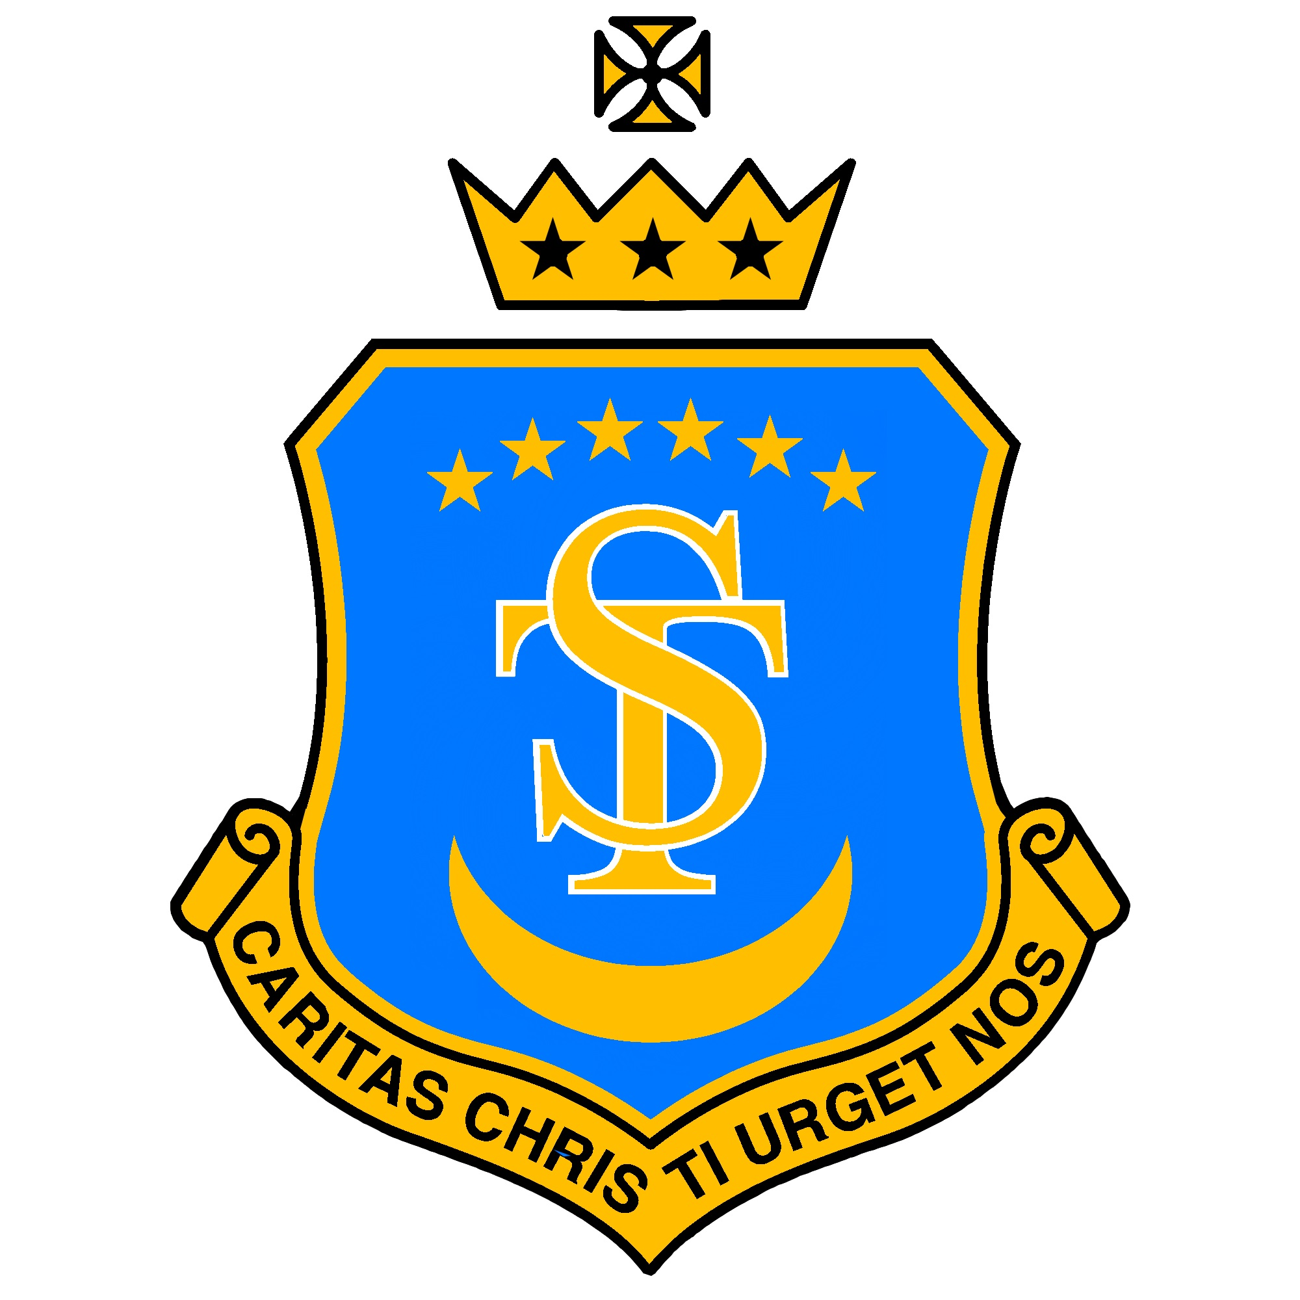

St Teresa’s Catholic Primary School
“With Jesus we live, love and learn”
Feedback and Marking Policy 2026
Date policy last reviewed:
Last updated: 11/01/26
Signed by:
 | Headteacher | Date:
 | Chair of governors | Date:

“Encourage one another and build one another up.”
(1 Thessalonians 5:11)
FEEDBACK & MARKING POLICY
Purpose and Rationale
At St Teresa’s Catholic Primary School, our focus in marking and feedback is simple and uncompromising: supporting children’s learning.
High-quality feedback and marking are central to excellent teaching. They help pupils understand what they have done well, what they need to improve, and how to move their learning forward. Feedback is most effective when it is timely, purposeful, and clearly linked to learning intentions.
This policy reflects current classroom practice and aligns with Ofsted’s emphasis on feedback that is meaningful, manageable, and impactful. It prioritises professional judgement over workload-heavy approaches and recognises that feedback can take many forms.

Core Principles
Effective feedback at St Teresa’s:
- Focuses on the quality of the pupil’s work against the learning intention, not comparison with others
- Identifies clear next steps and provides opportunities for pupils to act on them
- Recognises progress over time, not just outcomes
- Builds pupils’ confidence, resilience, and independence as learners
- Is proportionate, sustainable, and supports staff wellbeing
Feedback should create a clear learning dialogue between teacher and pupil and be understood by both.

Aims of Feedback and Marking
Feedback and marking should:
- Celebrate effort, achievement, and progress
- Clearly identify strengths and areas for development
- Support pupils to understand what success looks like
- Help pupils take ownership of improvement
- Identify pupils requiring additional support or challenge
- Inform future teaching and planning
- Support accurate assessment against age-related expectations
- Provide meaningful evidence for pupils, staff, leaders, parents, and inspectors

Forms of Feedback
Feedback may be verbal, written, or observational, depending on what will have the greatest impact on learning.
Verbal Feedback
Verbal feedback is a highly effective and often preferred method. It is immediate, responsive, and allows pupils to clarify understanding in real time.
It may occur:
- During lessons
- In group work or interventions
- In conferencing or guided sessions
Where appropriate, verbal feedback should be acknowledged using the agreed symbol (see Appendix 1).
Written Feedback
Written feedback should be:
- Clear, concise, and purposeful
- Focused on learning, not quantity of marking
- Used selectively where it will add value
All work is acknowledged as part of our commitment to valuing pupils’ learning.
Marking conventions:
- RED pen: adult comments/feedback
- GREEN pen: pupil response/self-assessment
- GREEN highlighter: learning intention met/ success criteria met
- ORANGE highlighter: learning intention not yet met/ next steps
Consistency in notation is essential across the school.

Next Steps and Challenge (Dive Deeper)
Where written next steps or challenge tasks are provided, they will:
- Be linked directly to the learning intention
- Celebrate success as well as identify improvement
- Be manageable and meaningful
- Be followed by time for pupils to respond
Learning time to act on feedback is essential and may take place within the lesson or in a planned follow-up.

Subject-Specific Guidance
English and RE
English marking should provide in-depth feedback that supports pupils in developing the clarity, quality, and impact of their writing. Feedback should:
- Respond to content, meaning, and effectiveness, not only technical accuracy
(e.g., ideas, structure, tone, coherence, clarity for the reader).
- Treat writing as communication with a real audience, commenting on how well the piece meets its purpose and engages the reader.
- Identify strengths and provide specific guidance for improvement, focusing on the most significant next steps for the pupil’s writing.
- Address spelling, punctuation, and grammar selectively, prioritising:
  - errors that impede meaning,
  - skills that have been recently taught,
  - high-value vocabulary pupils are expected to use accurately.
RE marking should provide thoughtful, developmental feedback that strengthens pupils’ subject knowledge and ability to explain and evaluate religious ideas. Feedback should:
- Prioritise pupils’ understanding, use of evidence, and accuracy of subject knowledge.
- Give specific guidance on how to deepen or clarify explanations, make links between beliefs and practices, or improve evaluative comments.
- Correct spelling selectively, focusing on key religious vocabulary pupils must learn and use with precision.
- Highlight strengths and identify clear next steps in pupils’ reasoning and written communication.

Mathematics
- Feedback is primarily diagnostic and informs next lesson teaching
- Marking identifies misconceptions and supports resilience and perseverance
- Same-day intervention or maths surgeries are used where appropriate
- Written next steps are used sparingly, as progression is typically addressed through lesson design/ challenge stickers
Foundation Subjects
- Feedback focuses on subject-specific skills, subject vocabulary and knowledge
- Next steps stickers or challenge tasks extend learning rather than repeat it

Correction and Presentation
- Not all errors are corrected; over-marking is discouraged
- Mistakes are viewed as valuable learning opportunities
- Rubbing out is discouraged; corrections should be made beside original work
- High standards of presentation are expected, appropriate to age and need

Pupil Involvement
Pupils are supported to develop independence through:
- Clear learning intentions and success criteria
- Self and peer assessment
- Opportunities to reflect and improve with next steps given by the class teacher
- Understanding what quality work looks like through modelling

Monitoring and Review
This is a whole-school policy and applies to all staff.
Implementation and impact are monitored through:
- Lesson visits
- Book scrutiny
- Professional dialogue
Feedback from monitoring is used to share best practice and support professional development.
This policy will be reviewed annually by staff and governors.

Appendix 1: Marking Codes (Existing agreed codes retained to ensure continuity and consistency.)
Code | Meaning
_____ SP | Spelling mistake, please correct
_____SPx3 | Spelling mistake, please practise a few times
I | Independent work (only use if the fact that the work is independent is of note. Most children’s work will be independent most of the time)
WS | With support. If this child had additional adult support to complete the work.
DD: | Dive deeper task (if not on already started on a sticker)
VF | May be used to indicate that verbal feedback was given.
 | Teacher: SC met/answer correct
 | Teacher: SC not met/next steps
✓ | Student: SC met/answer correct
. | Student: SC not met/incorrect
 | Learning intention met
 | Learning intention not met
Examples of live marking and/or feedback
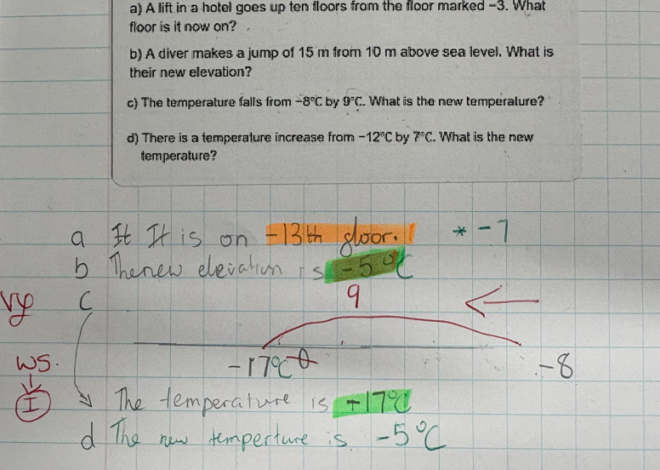
Green used to highlight success. Orange for next steps or areas to think again. Child responds in green pen. VF used to show verbal feedback given. WS moving to I codes used when appropriate. Modelled feedback using red pen.
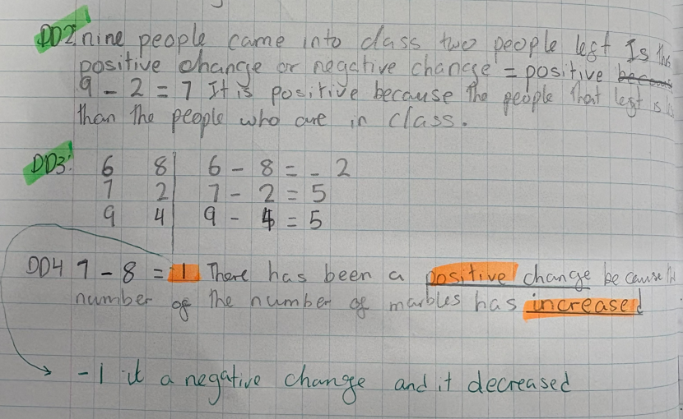
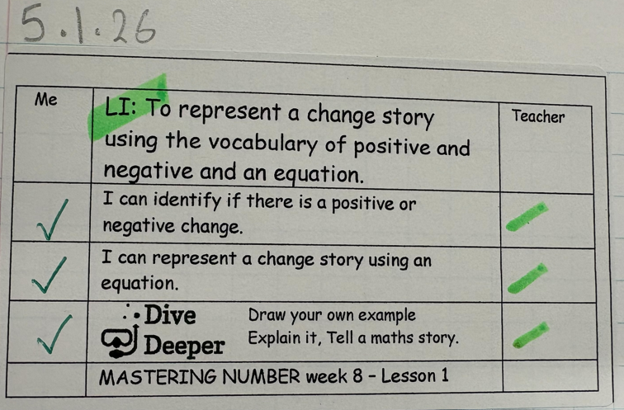
Learning intention highlighted green to show it has been met. Orange within the SC when appropriate to show areas for next steps. The Learning Wheel Heads have been used in foundation subjects to demonstrate the learning. Teacher marks individual SC in green highlight (or orange when needed). Children self assess in green (appropriate to their age)

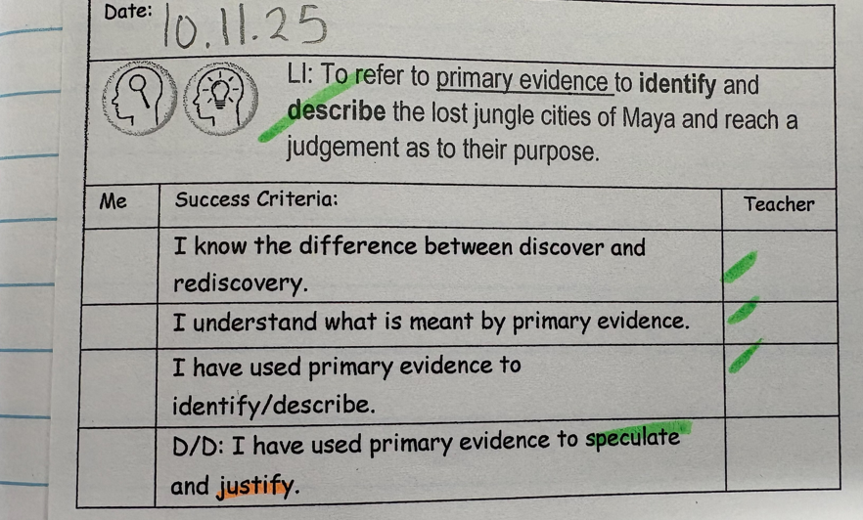

Next step stickers for foundation subject: examples
These challenge the children to think more deeply about their learning.
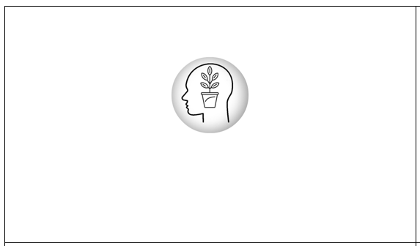

Examples:


