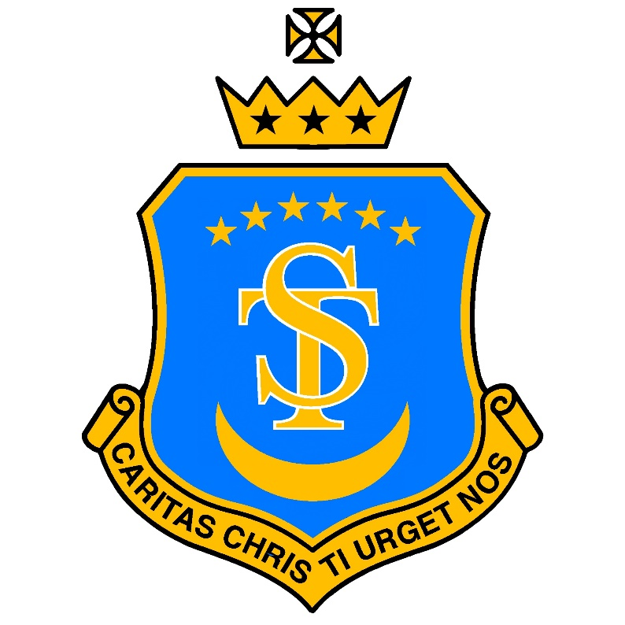

St Teresa’s Catholic Primary School
“With Jesus we live, love and learn”

Progression in Prayer Explained

“For me, prayer is a surge of the heart; it is a simple look turned toward heaven.”
— St Thérèse of Lisieux

How Prayer and Liturgy Progress Through the School
At St Teresa’s Catholic Primary School, prayer and liturgy develop gradually, intentionally, and reverently as children grow in age, understanding, confidence and faith. Progression is not simply about learning more prayers, but about deepening relationship with God and increasing participation and leadership.
1. Early Years (Nursery & Reception): Experiencing God’s Love
In the Early Years, prayer is sensory, simple and relational.
Children are helped to:
- Experience prayer as something joyful, calm and safe
- Learn that God loves them and is close to them
- Learn that prayer is how we speak to God
- Join in short, repeated prayers with actions, gesture and song
- Make the sign of the cross
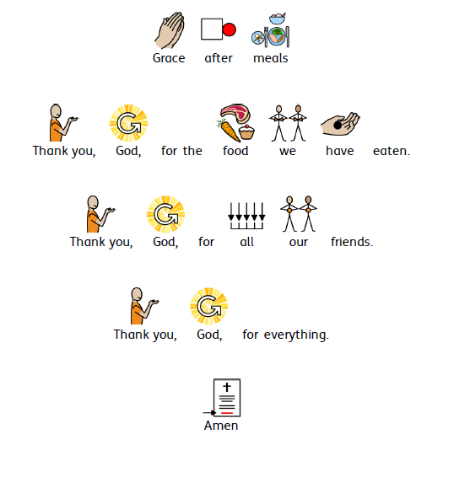
- Say “Amen” as a response
Prayer and liturgy include:
- Very short daily prayers at key moments (morning, mealtimes, home time)
- Simple language and repetition
- Use of visuals, symbols, candles and images
- Support through widget symbols
- Listening quietly for short periods
- Making the Sign of the Cross with support
The focus is on developing belonging, familiarity and wonder

2. Key Stage 1 (Years 1–2): Learning to Pray Together
In Key Stage 1, children begin to understand that prayer:
- Is a way of talking and listening to God
- Happens at regular points in the day
- Can be spoken, sung or silent
Children are taught to:
- Join confidently in school and traditional prayers (see prayer book)
- Begin to pray together as a community
- Show reverence through posture, stillness and gesture
Prayer and liturgy develop through:
- Structured daily class prayer (morning, grace, end of day)
- Introduction to traditional prayers in age-appropriate language (see prayer book)
- Listening to short Gospel stories
- Simple whole-school liturgies with guided participation
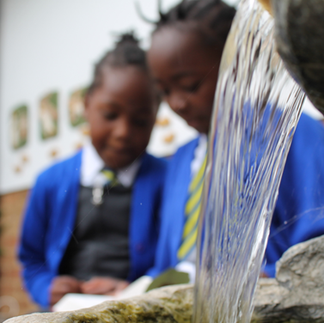
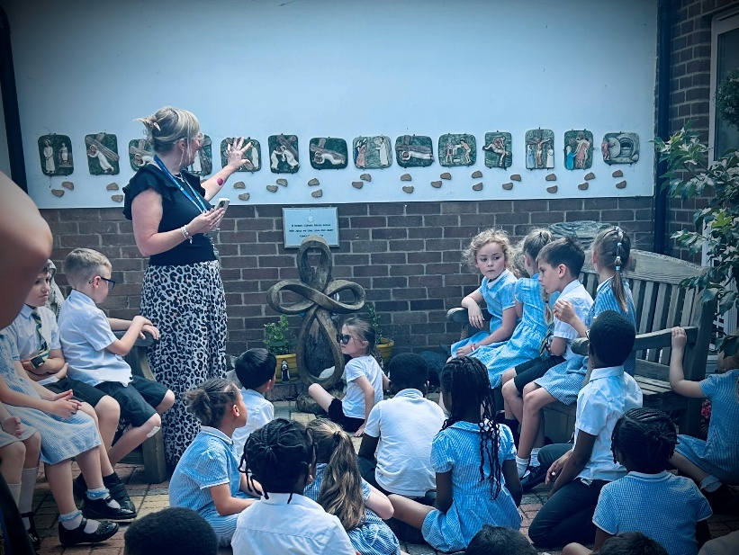

Children move from exploring and copying prayer to participating intentionally

3. Lower Key Stage 2 (Years 3–4): Deepening Understanding
In Lower Key Stage 2, children deepen both understanding and independence.
They are supported to:
- Understand the meaning of prayers they say
- Listen attentively to Scripture
- Reflect quietly and respond thoughtfully
- Begin to offer simple spontaneous prayers
Prayer and liturgy now include:
- Longer periods of silence and reflection
- Growing knowledge and use of traditional prayers for Ks2 (See prayer book)
- Guided intercessory prayer
- Greater familiarity with the structure of Celebration of the Word
- Growing awareness of the Liturgical Year
- Participation in Mass with clearer understanding of responses and actions
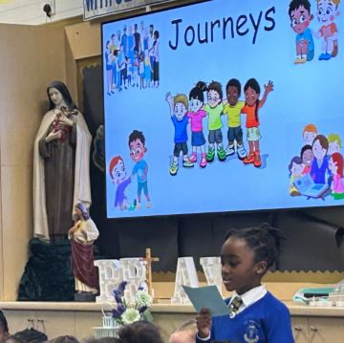
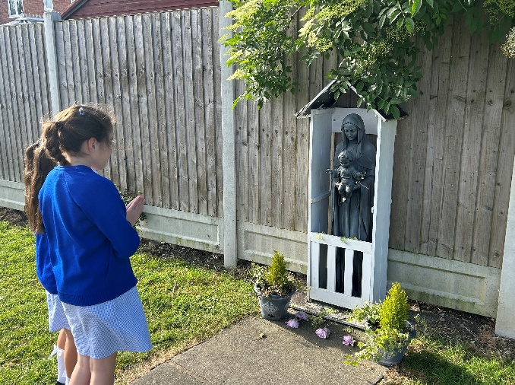
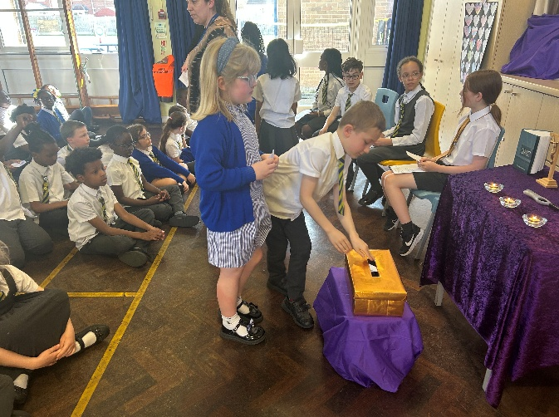
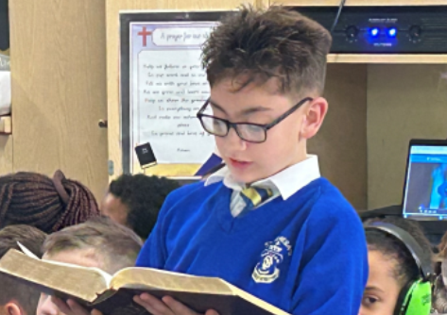
Prayer becomes more reflective, personal and Scripture-rooted
4. Upper Key Stage 2 (Years 5–6): Leading and Owning Prayer
In Upper Key Stage 2, children are prepared to leave primary school as confident, reverent participants in the prayer life of the Church.
They are enabled to:
- Write and lead spontaneous prayers
- Prepare and lead parts of liturgy and worship
- Engage deeply with Scripture
- Participate fully and reverently in Mass
- Understand prayer as part of daily Christian life, not just school routine
Prayer and liturgy include:
- Pupil-led Celebrations of the Word
- Writing and proclaiming intercessions
- Leadership roles in Mass (readers, offertory, servers where trained)
- Reflective responses to Gospel messages
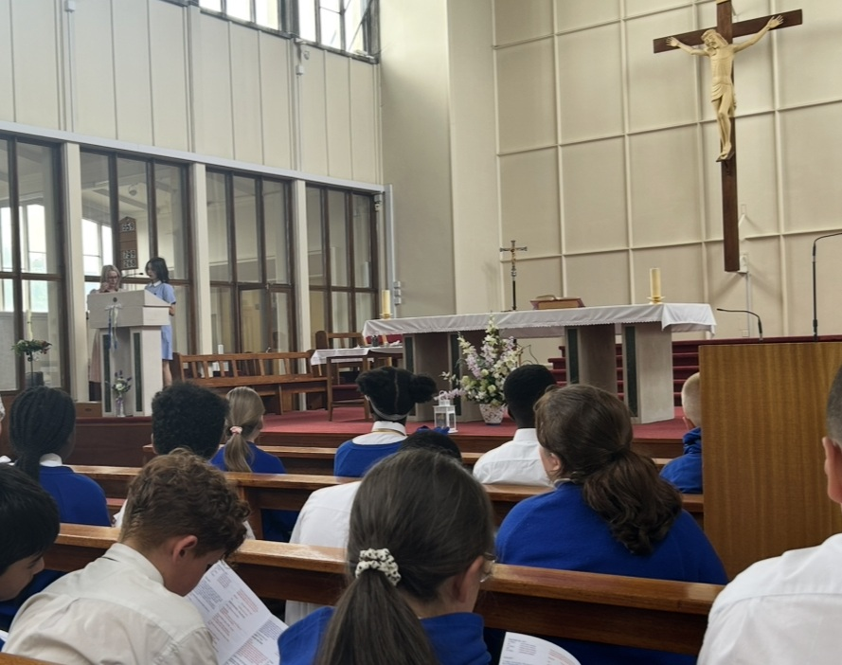
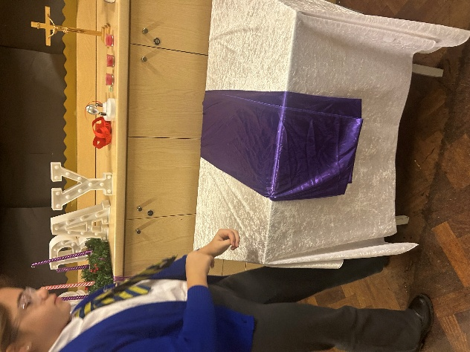
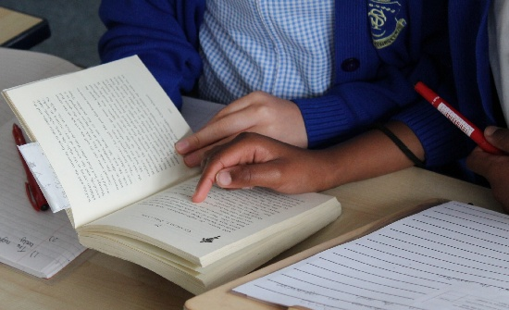
- Prayer linked to justice, mission and “going forth”
By Year 6, pupils move from participation to ownership and leadership of prayer

5. A note on inclusion and Continuity Across the School
Throughout all stages:
- Prayer is inclusive and accessible for all pupils
- Widgit symbols and visual supports ensure full participation
- Children with SEND engage meaningfully through adapted language, gesture and sensory prayer
- A shared repertoire of prayers unites the whole school community

