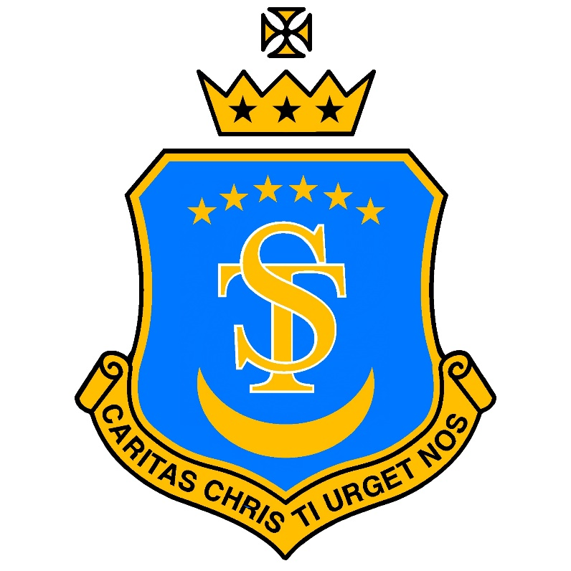
St Teresa’s Catholic Primary School
“With Jesus we live, love and learn”

RE Policy

Date policy last reviewed:
Last updated: 24/11/25
Signed by:
 | Headteacher | Date:
 | Chair of governors | Date:

Religious Education (RE) Policy
"Let us thank all those who teach in Catholic schools. Educating is an act of love; it is like giving life." - Pope Francis
1. Catholic Identity & Mission
At St Teresa’s Catholic Primary School, Religious Education is the core and most important subject we teach. Families choose our school because of our strong Catholic identity, and RE shapes the ethos, curriculum and daily life of our school.
RE forms the heart of our mission to help every child encounter Christ, grow in virtue, understand the teachings of the Church, and joyfully live out the Gospel.

2. Parish Partnership
We belong to the Parish of Our Lady and All Saints and worship at St Basil the Great.
Our parish priest, Father Sabu, is also a school governor. He, and other RE link governors, visits the school regularly to:
• Monitor RE lessons
• Quality-assure Catholic life and RE provision
• Ensure fidelity to the teachings of the Catholic Church
• Support teachers and pupils in deepening their understanding of the faith

3. Chaplaincy & Catholic Life
We have a Faith Council who lead charity events, support Catholic social teaching, and help promote the Catholic mission of the school.
The Headteacher, Deputy Head and Assistant Head/RE Lead lead collective worship three times a week. Worship includes Scripture, reflection, prayer, and teaching linked to liturgical seasons. This enriches, but does not replace, curriculum RE.

4. Curriculum Model and the Religious Educational Directory
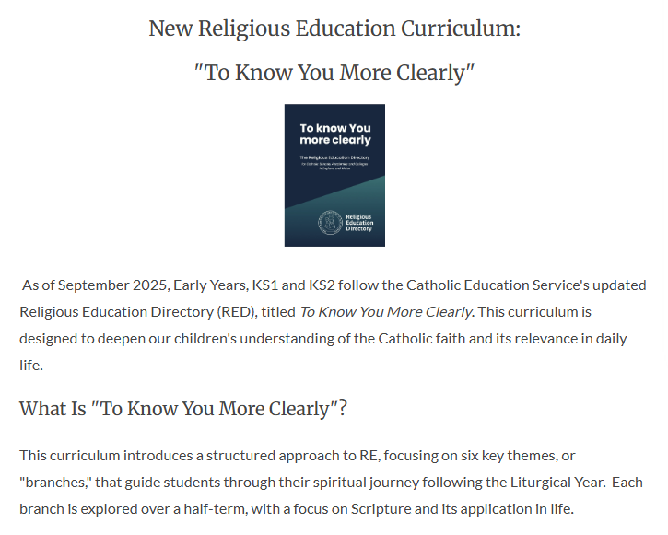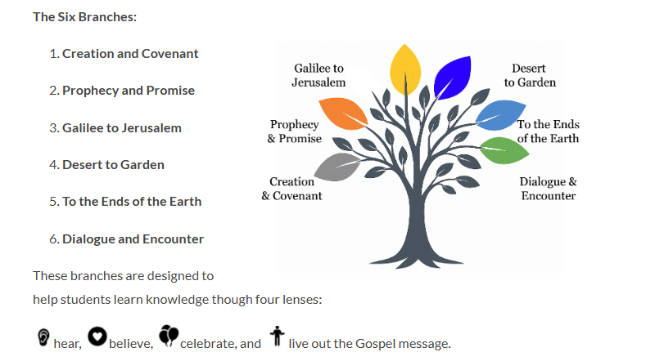
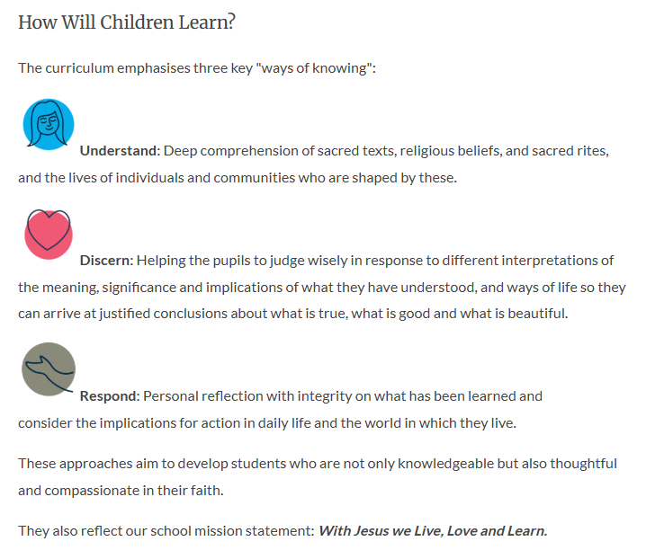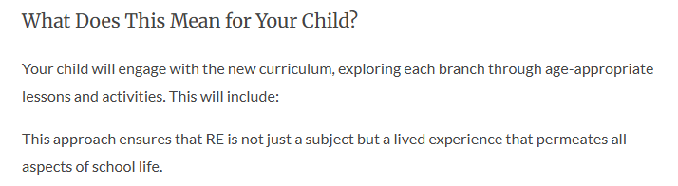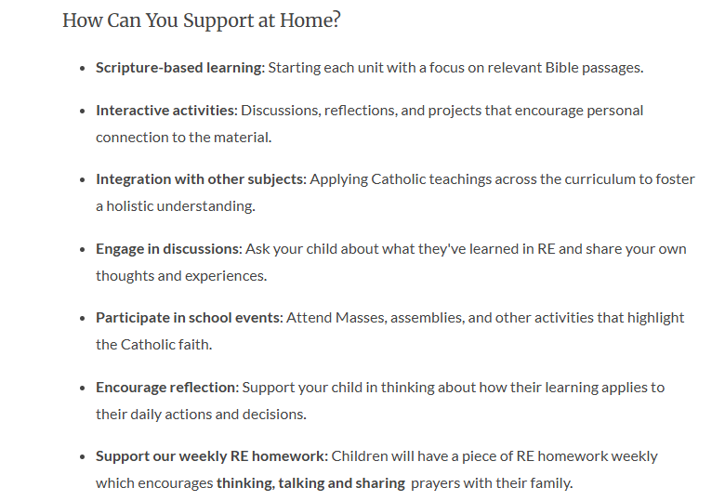

5. Time Allocation
We dedicate at least 2.5 hours each week to the RE curriculum. This is separate from:
• Collective worship
• Hymn practice
• School or class Mass
• PSHE
• RSE
Typically, this means between two and three RE lessons a week (depending on the length of the lessons.)
6. Teaching & Learning
RE is taught with high academic and spiritual expectations. Lessons encourage children to:
• Understand – know and explain Church teaching
• Discern – apply, consider, reflect
• Respond – express their own thoughts, prayers or creative responses
RE must only be taught by a member of staff with QTS and suitable training to deliver RED lessons. (The only exception may be a confident trainee teacher, nearing QTS, who would only do this under the supervision of the class teacher/mentor).

7. RE Working Walls
Each classroom must have an RE Working Wall.
Details for this can be found in the working wall policy.
Working walls are functional, regularly updated, and accessible. They support learning and should be used by children independently.

8. Prayer Tables
Every classroom must have a prayer table containing:
• White tablecloth
• Green, white and purple runners (for specific liturgical seasons)
• One religious statue
• Age-appropriate Bible
• Bible stand to enthrone the Bible
• Candle (or electric substitute)
• Rosary, rosary card, blue mat (May & October)
• Class prayer intentions book
• St Teresa statue
The cloth changes with the liturgical season. Prayer tables must be uncluttered, beautiful, and treated reverently. Children must help to design and arrange this table.

9. Sacramental Preparation
The parish leads the First Reconciliation and First Holy Communion programme.
The school supports by:
• Ensuring staff attend the enrolment Mass and First Communion Mass
• Building strong links with catechists
• Welcoming catechists into school to meet children
• Supporting families pastorally
• Providing ample opportunities to attend and interact with the mass during a school year.

10. Catholic Social Teaching (CST)
CST is woven through:
• RE lessons
• PSHE
• Collective worship
• Faith Council charity work
Children learn about stewardship, dignity, solidarity, the common good, and justice.

11. RE Books
RE books are special and treated with reverence. They:
• Have plastic covers
• Include artwork on the front
• Are stored in a special basket near the prayer table
• Are never placed on the floor
Children are taught from the early years to respect the sacred nature of their RE books.

12. Assessment
Formative assessment:
• Ongoing in lessons
• End-of-unit tasks assessing understanding, discernment and response

Summative assessment:
• Three data drops each year
• Judgements recorded as:
– Working at age-related expectations
– Working below
(Currently, no “greater depth” standard is available for the RED. This will be updated as guidance is received.)

13. Monitoring & Evaluation
Monitoring is carried out by:
• RE Lead (Assistant Head)
• SLT
• Governors including Father Sabu
• Diocesan advisers
• Peer reviews from external schools
Includes: book looks, learning walks, working wall checks, worship monitoring, pupil voice and data analysis.

14. The Right to Withdrawal
Religious Education and Prayer and Liturgy (Collective Worship) form an integral part of everyday life at St Teresa’s but we work in keeping with CES guidance on ‘The Right to Withdraw from RE and Collective Worship"

14. Review Cycle
This policy is reviewed every three years, or earlier if required by the Diocese or Bishop. All updates require full Governing Body approval.

