

St Teresa’s Catholic Primary School

School Prayers

“With Jesus we Live, Love and Learn”

Contents:
This booklet aims to support parents in knowing our school prayers, traditional Catholic prayers that their child may be learning and may be used to support saying prayers at home.

- 3) Our School Prayer.
- 4) The Christus Catholic Trust Prayer.
- 5) Daily Prayers.
- 6) Traditional Prayers Ks1.
- 7) Traditional Prayers Ks2.
- 9) Spontaneous Prayer Guidance
- 10) Widgit Prayer Resources.
- 18) Widgit Spontaneous prayer support.
Our School Prayer

Help us follow in your footsteps
In our work and in our play
Fill us with your love and joy
As we grow and learn each day
Help us show the greatest love
In everything we do
And make our school a happy place

In praise and love of you

Amen

The Christus Catholic Trust Prayer

Dear Lord
We Thank You for the gifts of our pupils, staff and leaders of the Christus Catholic Trust.
We ask You to bless and guide our thoughts, words and actions. In all we do, may our young people grow in wisdom and stature o come to know, love and serve You.
This we ask through Jesus Christ, true God and true man, living and reining with You the Father forever and ever.

Amen.

Daily Prayers:


KS1 Morning Prayer:

Oh my God you love me
You’re with me night and day
I want to love you always in all I do and say.
I’ll try to please you Father.
Bless me through the day. Amen.
KS2 Morning Prayer:

Oh Jesus, through the most pure
heart of Mary, I offer to you,
the prayers, works, sufferings
and joys of this day,
for all the intentions of thy
divine heart and the Holy Mass.
Amen

KS1 Grace before lunch:

Bless us, O Lord, as we sit together
Bless the food we eat today,
Bless the hands that made the food,
Bless us, O God.
Amen.
KS2 Grace before lunch:

Bless us, O Lord, for these Thy gifts,
which we are about to receive from Thy bounty.
through Christ our Lord.
Amen.

KS1 Grace after lunch:

Thank you, God, for the food we have eaten.
Thank you, God, for all our friends.
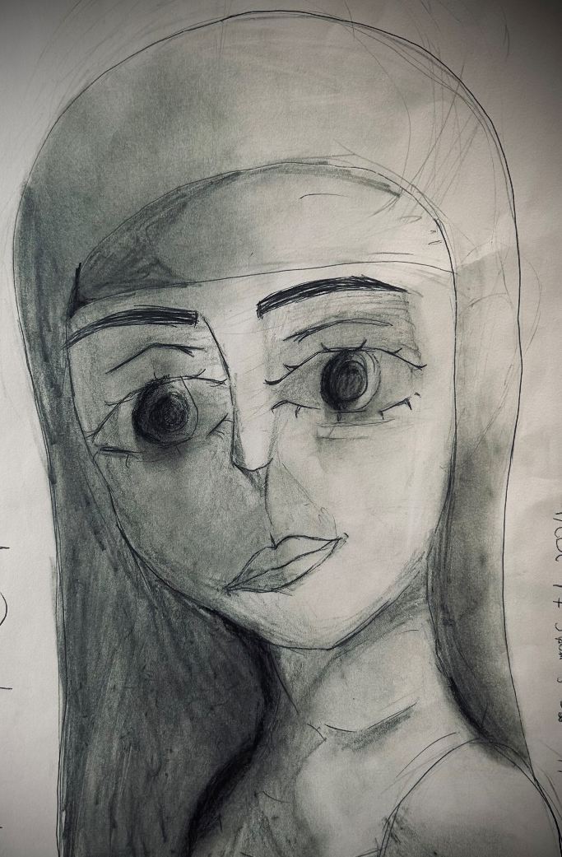
Thank you, God for everything
Amen.
KS2 Grace after lunch:

We give you thanks,
Almighty God,
for all your benefits,
who live and reign,
world without end. Amen.

KS1 End of the day prayer:

Goodnight, dear Jesus and
thank you I say,
for being my companion
at work and at play.
Amen.

KS2 End of the day prayer:

God our Father,
I’ve come to say
Thank you for Your love today
Thank you for my family
And all the friends you give to me
Guard me in the dark of night
And in the morning, send your light.
Amen
Key Stage One: Traditional Prayers
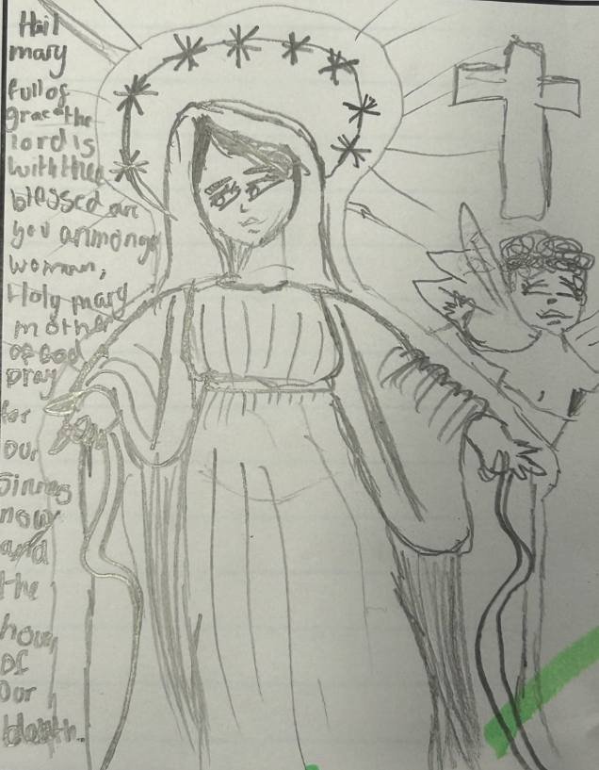
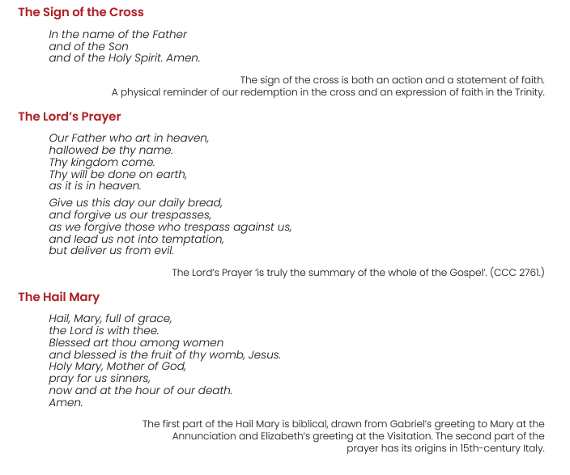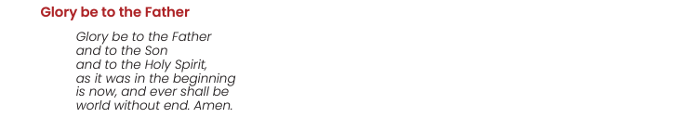

Key Stage Two: Traditional Prayers

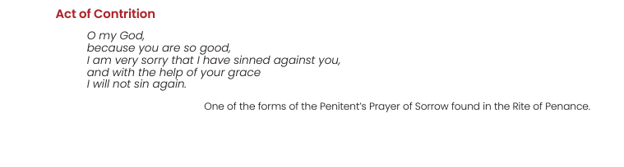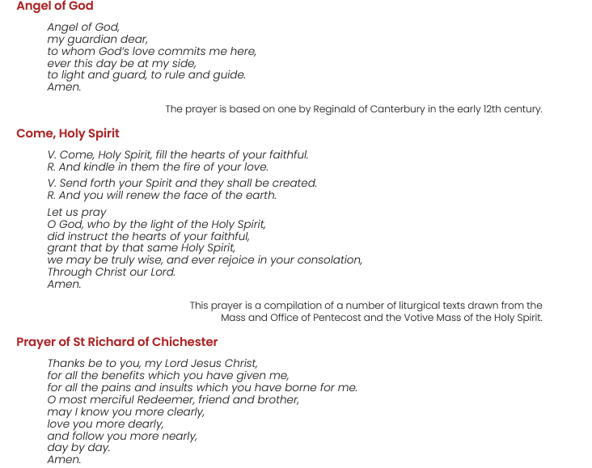

The Angelus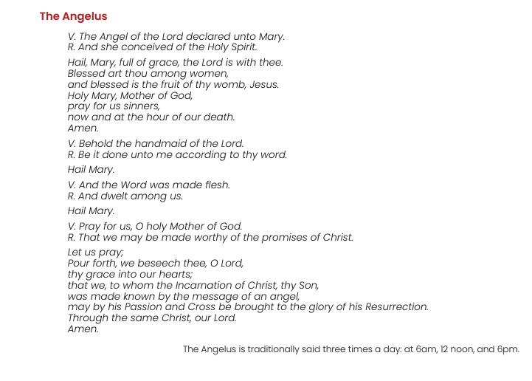
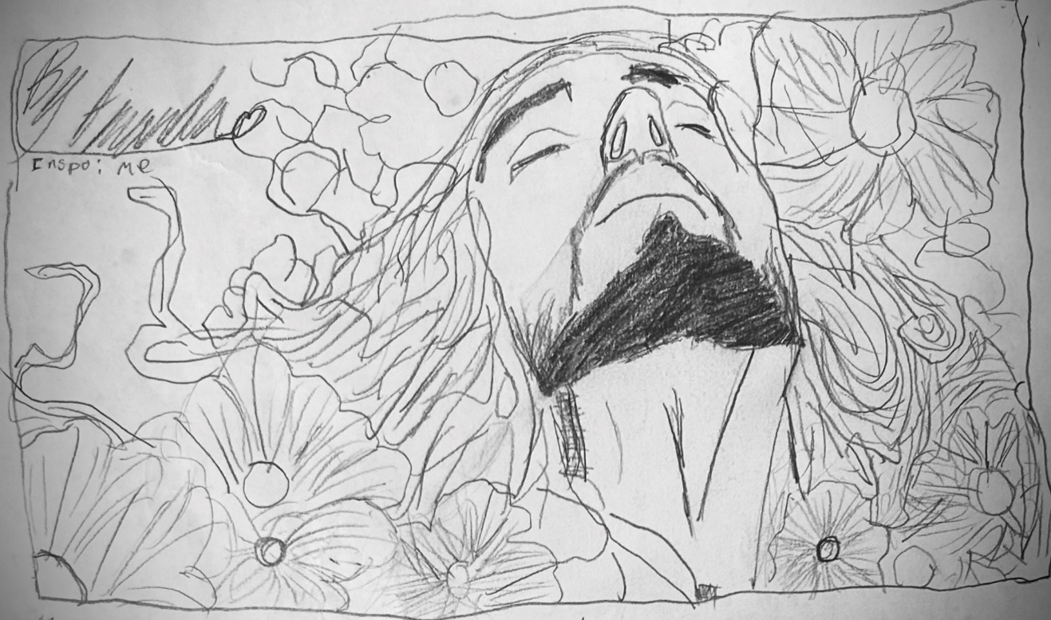
Spontaneous Prayer

As well as learning school and traditional prayers, we teach our children the importance of spontaneous prayer as well. These are the moments that we may want to connect with God to express thanks, joy, sorrow or call for help. These moments are just as important as our daily prayers and allow children to develop some agency in the creation of prayer and their relationship with God.
Below are some suggestions for when spontaneous prayer may be suitable at home:

- To express thanks for something.
- To express joy about something.
- To pray for someone in need.
- To pray for support and guidance.
- To pray for forgiveness after making a mistake.
- To pray for courage when scared.
- To pray for understanding when confused.
- Any time you wish to communicate with God.

You may remind your child as well that sometimes prayer is something shared with others and said out loud. Other times it is something private, said in one’s mind.

Widgit Prayer Resources

(In our school Widgit symbols are predominantly used to support the learning of those with additional communication needs. However, these may also be used with younger children too. These resources can be used as a method of learning prayers with greater ease, teaching the meaning behind prayers and an additional Widgit word mat is available for helping a child to create their own spontaneous prayer, removing the barrier of spoken and written language)
The Sign of the Cross (Widgit)
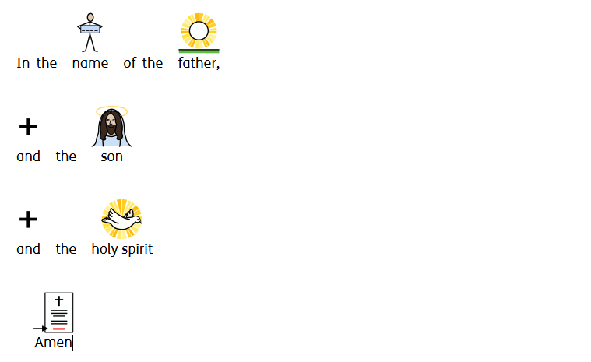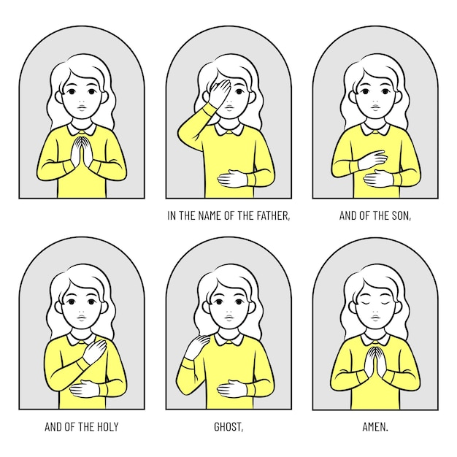
School Prayer (Widgit)
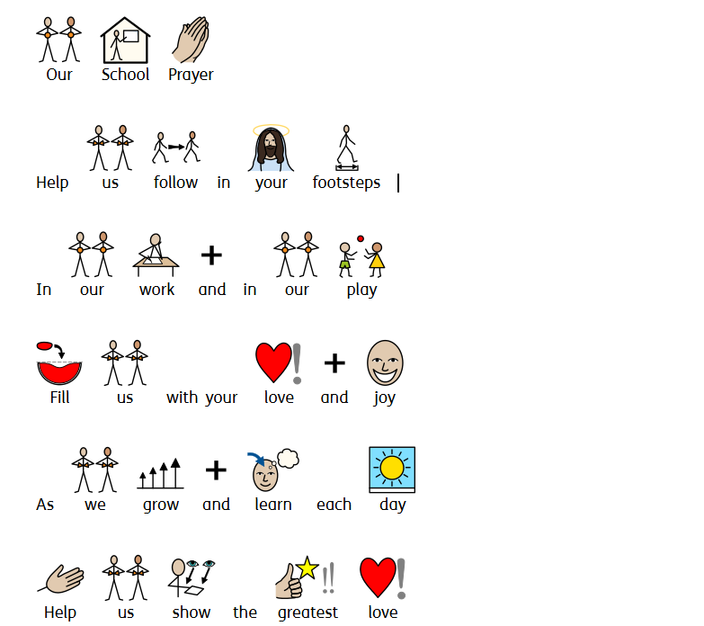
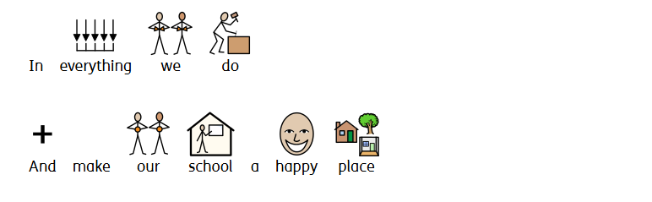

Morning Prayer (Widgit)
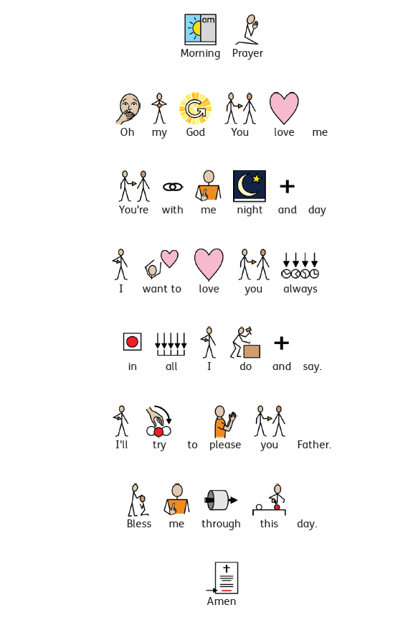

Grace Before Lunch (Widgit)
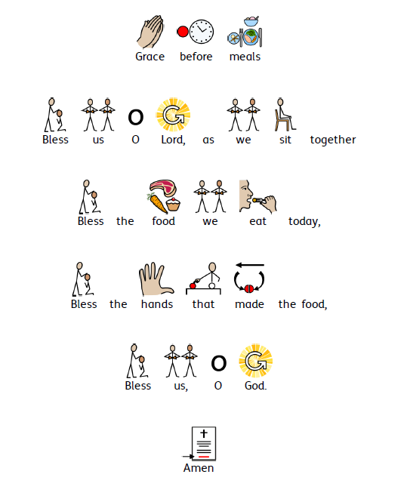

Grace After Lunch (Widgit)

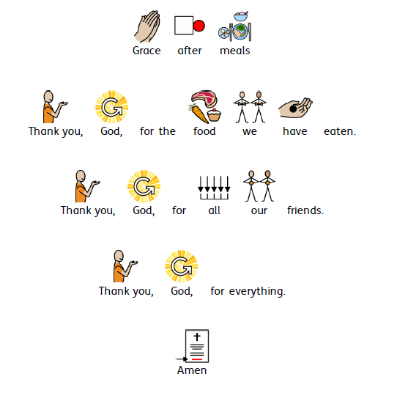
End of Day Prayer (Widgit)
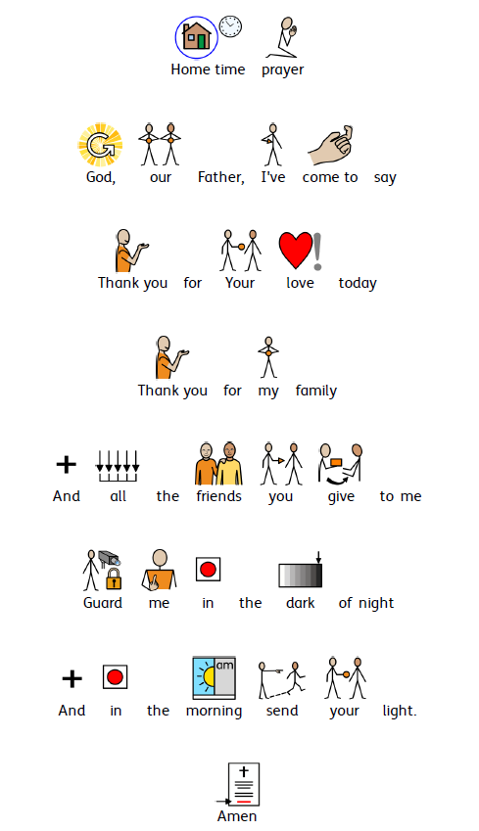

The Lord’s Prayer (Widgit)
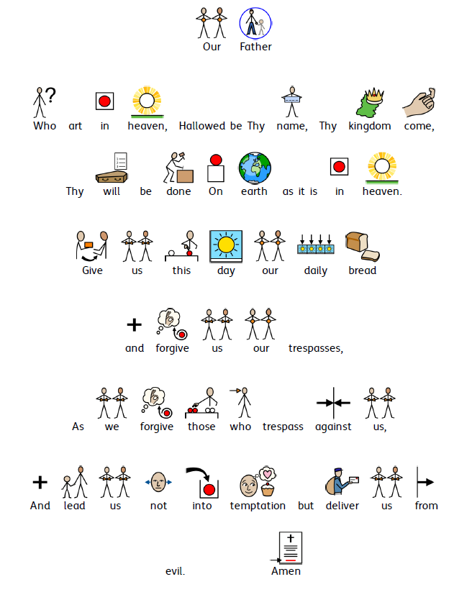

The Hail Mary (Widgit)

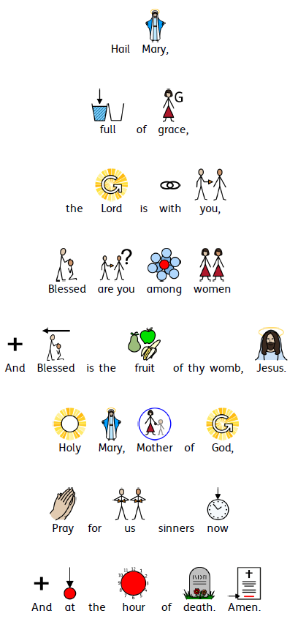

Spontaneous Prayer Support (Widgit)
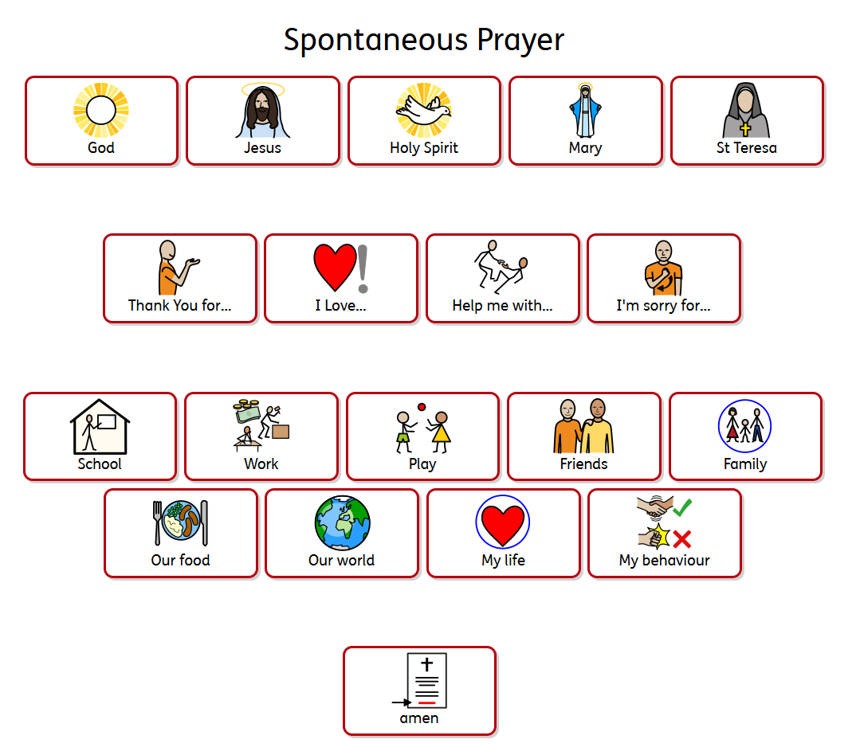
This resource can help a child with limited communication create a spontaneous prayer.
- In the top section we address our prayer. (Remember to remind children that we can ask Mary of St Therese to hear our prayer and help take it to God but it is still God that we are praying to.)
- In the second section, the child can express why they are praying. It could be for thanks, support or forgiveness for example.
- Then we have a list of things that the child may be praying about. This list is of course non-exhaustive, but it may give some children some ideas.
- Finally, we end with “Amen”. Children may practice putting their hands together or making the sign of the cross.

