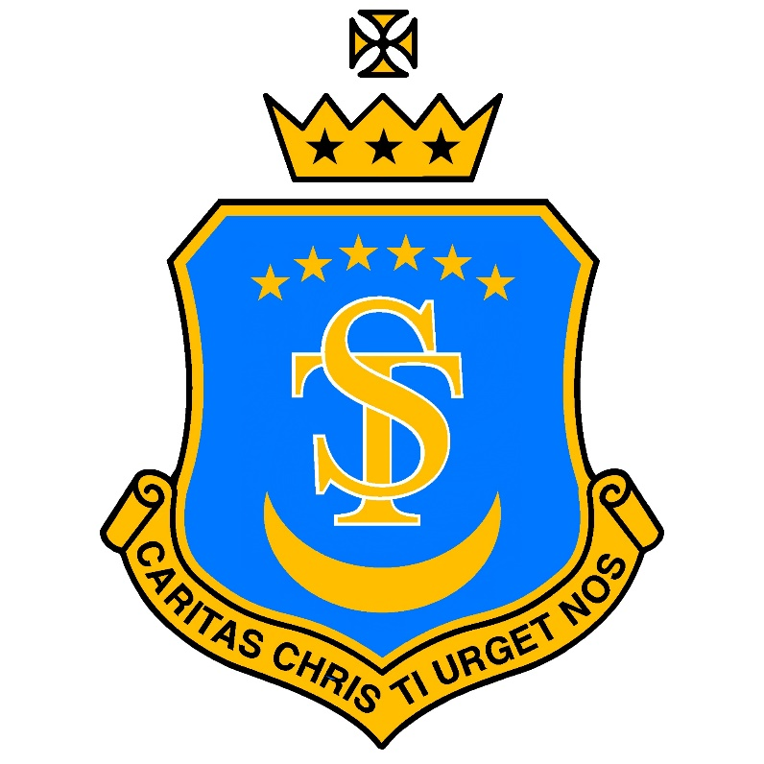

St Teresa’s Catholic Primary School
“With Jesus we live, love and learn”

Uniform Policy

Date policy last reviewed: | 2025
Last updated: December 2025
Signed by:
 | Headteacher | Date:
 | Chair of governors | Date:

(Updates to the policy are in red)
“Let all of you then live together in oneness of mind and heart, mutually honouring God in yourselves, whose temples you have become.”
- St Augustine of Hippo
Aims and objectives
Our policy on school uniform is based on the belief that school uniform:
• Helps to create a sense of community and belonging towards the school;
• Supports our commitment to inclusion;
• Promotes a sense of pride in our school;
• Identifies the children with the school;
• Prevents children from wearing fashion items that could be distracting in class;
• Is practical, smart and designed with health and safety in mind;
• Is good value for money.
Jewellery Make-up and Nail Varnish
For health and safety reasons, and to ensure full curriculum entitlement, we do not allow children to wear jewellery except simple stud earrings (which are worn at the parent’s risk).
The only exception to this is a watch that is fitted to the wrist for children in Key Stage Two. Smart watches or devices worn on the wrist that can connect to the internet, record or photograph are not permitted. Watches are worn at the parent’s risk and parents are encouraged not to send children in with expensive wristwear.
Make-up and nail varnish are not permitted at school, unless for an out-of-school-hours function such as a school disco.

Hair
Compliant Non-Compliant
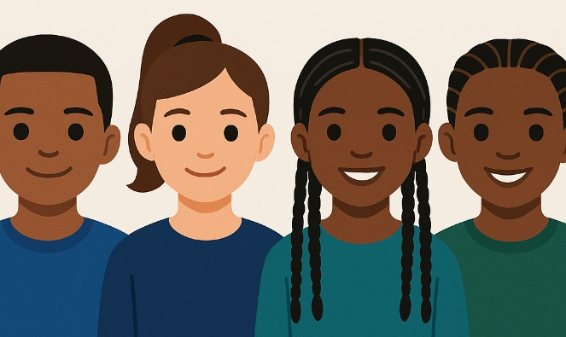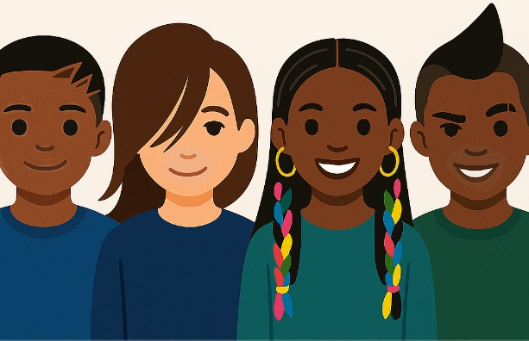
Hair bands, ribbons, bows or scrunchies should be plain or in the school colours. Hair bands should not have ornamentation attached (e.g. flowers).
All long hair must be tied back with suitable elastics, hair ties, clips or bands. Coloured hair is not acceptable in school. This includes dyeing, bleaching, highlights or lowlights, coloured hair extensions, plaits or braids.
Extreme hairstyles, such as a Mohican, are not appropriate for school. The use of styling products should be kept to a minimum, and children should not have decorative patterns cut into their hair or eyebrows.
Parents of children who come to school with unacceptable hairstyles will be contacted and given until the following weekend to rectify it.
Inclusivity and Afro-Textured Hair
The school values the cultural and community importance of Afro-Caribbean hairstyles. The school also recognises that Afro-textured hair is structurally different from straight or wavy hair. Styles such as cane-rows, plaits, and adorned braids are deeply rooted in history and identity. Recognising these traditions helps children to feel seen, confident, and respected in their natural state. For this reason, protective styles -such as braids, plaits, twists, and cane-rows -are encouraged and supported for students with afro-textured hair.
Beads and adornments in Afro hair may be used for both protective and cultural reasons. Beyond their practical purpose, beads often carry cultural significance and heritage through colour, pattern, and design. That said, beads in hair should not be excessively large as this can cause safety issues when children play and move quickly. As much as possible, they should reflect the school’s colours.
To ensure consistency with our wider uniform expectations, protective and cultural hairstyles should be neat, well-maintained, and safely secured for learning and physical activity. Staff and families are encouraged to work in partnership to ensure hairstyles meet both health and safety requirements and reflect the school’s inclusive ethos.
Hair: Ask first if unsure
If a parent is unsure about something that they are planning on doing to their child’s hair, please ask first. Expensive processes that cannot be easily undone may not comply with the uniform policy and parents may be asked to change their child’s hair back. To avoid this scenario, if something that is not covered in the above two sections is being considered, please ask first and a member of the Senior Leadership Team will provide clarity, seeking external cultural advice if necessary.
Parents of children who come to school with hairstyles that fall outside of these guidelines will be contacted and supported to make appropriate adjustments by the following weekend.

Footwear
For health and safety reasons we do not allow children to wear shoes with platform soles or high heels. All children are required to wear plain black shoes without logos as stated in the uniform list. School shoes should not be styled to look like trainers. If boots are worn to travel to/from school, they should change into school shoes whilst inside the school building.
The Role of Parents
It is the responsibility of parents to ensure that their child has the correct uniform and PE kit, that it is clean, in good repair and that the child’s name is clearly marked on all item. If a parent has difficulties for any reason in fulfilling these expectations, they are asked to speak confidentially to the Headteacher. Parents are assured that we will do all we can to help.
The Role of Governors
The Governing Board supports the Headteacher in implementing the school uniform policy. It considers all representations from parents regarding the uniform policy and liaises with the Headteacher to ensure that the policy is implemented fairly and with sensitivity. It is the governors’ responsibility to ensure that the school uniform meets all regulations concerning equal opportunities. Governors ensure that the school uniform policy enables children to dress sensibly, in clothing that is hardwearing, safe and practical.
Monitoring and Review
The governing board monitors and reviews the school uniform policy through its committee work by:
• Seeking the views of parents, to ensure that they agree with and support the policy;
• Considering, with the Headteacher, any requests from parents for individual children to have special dispensation with regard to school uniform.

The School Uniform
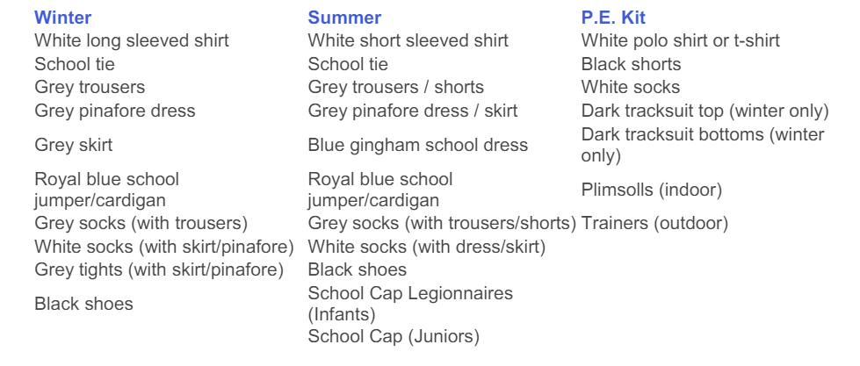PLEASE ENSURE THAT YOUR CHILD’S NAME IS IN EVERY ITEM OF SCHOOL CLOTHING
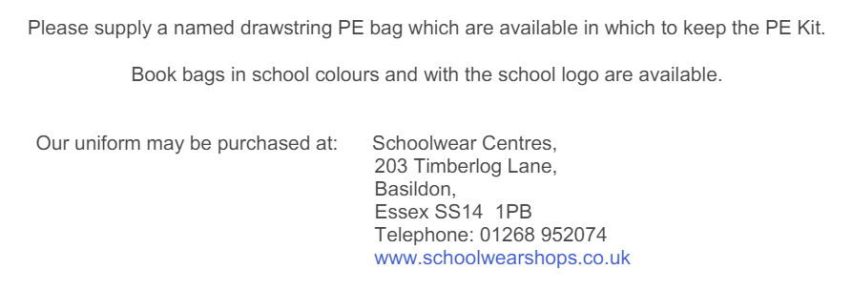
PLEASE NOTE – WE DO NOT INSIST ON A BRANDED ST TERESA’S SCHOOL JUMPER OR CARDIGAN. CHEAPER ALTERNATIVES BOUGHT IN SUPERMARKETS ARE ACCEPTABLE AS LONG AS THEY ARE A ROYAL BLUE COLOUR.



