



St. Teresa’s
Catholic Primary School
Special Educational Needs/Disabilities (SEND)
Information Report
2025-2026

Contents

Our School 4
School SEND Information September 2025 4
Meet our SENCO 4
Definition of Special Educational Needs and Disabilities (SEND) 5
SEND Broad Areas of Need 5
Cognition and Learning 6
Communication and Interaction 6
Social, Emotional and Mental Health 6
Sensory and Physical 7
Identification 7
Support for children with SEND 8
Curriculum Adaptations 9
Securing School Resources 10
Inclusion in all aspects of school life 10
Transition 10
Starting School 10
Nursery to Reception 11
End of Year Transition 11
Transition to Secondary School 11
Mid-Year New Starters 11
Evaluating Provision 12
Pupil Views 12
Parent Consultation 13
Support for Parents 14
Staff Training 15
Outside Agencies 16
Looked after Children (LAC) 18
SEND Policy 18
SEND Governor 18
Complaints 18
Essex/Thurrock Local Offer 19
Glossary 20

The aim of this information report is to explain how we implement our SEND policy. In other words, we want to show you how Special Educational Needs support works in our school.

We have high expectations for all the children in our care, but realise that some children may need different adaptations to school life in order to support them in achieving those high expectations.
If you want to know more about our arrangements for children with SEND, read our SEND policy. This can be found on our school’s website or on the Christus Catholic Trust website.
Note: If there are any terms we have used in this information report that you are unsure of, you can look them up in the Glossary at the end.

Our School | School SEND Information  "With Jesus we live, love and learn" - Our School Mission Statement.  At our Catholic primary school, we're guided by our mission statement: "Through Jesus we live, love, and learn." This means that everything we do is inspired by the teachings of Jesus Christ.  St. Teresa’s Catholic Primary currently has 219 children on roll.  There are currently 45 children (22%) on SEND register with a range of needs from universal to specialist.  15 children (7%) have SEND needs that can be accommodated through quality first teaching (universal need).  20 children (9%) have SEND needs that requires targeted interventions through quality first teaching and support planned by class teacher (targeted need) at SEN Support  6 children (3%) have significant/complex needs that require support over and above in class provision (specialist need) who are in the EHCP process  10 children have an Education, Health and Care Plan (4.5%)  The national statistics for pupils with SEND in January 2025 were 14.2% of children at SEN Support and 5.3% had an EHCP, making a total of 19.5%
Meet our SENDCo   | Faye Gillings is the school’s Special Educational Needs and Disability Co- ordinator (SENDCo) who is responsible for co-ordinating provision for children with SEND.  Faye is a qualified teacher with over 18 years’ experience working in a wide range of schools. She achieved the National Award in Special Educational Needs Co-ordination in 2025.  She keeps up-to-date with new research and accesses training provided through the Essex Local Offer, the Brentwood Diocese and other external agencies/providers.  If you would like to contact Faye, please call school on:  01268 553502 or email: f.gillings@st-teresasrc.essex.sch.uk  Your child’s class teacher will always be the first person to approach if you have any concerns about your child. The SENCO will support your child’s class teacher to meet with you and address your concerns.

Definition of Special  Educational Needs and Disabilities (SEND)   | A child or young person has SEND if they have a learning difficulty or disability which calls for special educational provision to be made for them. A child or young person has a learning difficulty or disability if they:  - has a significantly greater difficulty in learning than the majority of others of the same age, or  - has a disability which prevents or hinders them from making use of facilities of a kind generally provided for others of the same age in mainstream schools.  For children aged two or more (Early Years), special educational provision is educational or training provision that is additional to or different from that made generally for other children or young people of the same age by  mainstream schools, maintained nursery schools, institutions or by relevant early years providers.
SEND Broad Areas of Need
At St. Teresa’s Primary School, we support children with a variety of differing Special Educational Needs and Disabilities (SEND) and we pride ourselves on being a highly inclusive school with an ethos which encourages and celebrates diversity and difference.
SEND is categorised into the following four broad areas of need in the SEND Code of Practice (2015):
 |  |  | Cognition and Learning
 |  |  | Communication and Interaction
 |  |  | Social, Emotional and Mental Health
 |  |  | Sensory and Physical

Cognition and Learning | Children with cognition and learning difficulties will learn at a slower pace than other children and may have greater difficulty than their peers in  acquiring basic literacy or numeracy skills or in understanding concepts, even with appropriate adaptations. A child with a specific learning difficulty (SpLD) may have difficulty with one or more aspects of learning. This  includes a range of conditions such as dyslexia (difficulties with reading and spelling), dyscalculia (difficulties with maths), dyspraxia (difficulties with co- ordination) and dysgraphia (difficulties with writing).
Communication and Interaction | Children with speech, language and communication needs (SLCN) find it more difficult to communicate with others. They may have difficulty taking part in conversations, either because they find it difficult to understand what others say or because they have difficulties with fluency and forming  sounds, words and sentences. It may be that when they hear or see a word, they are not able to understand its meaning, leading to words being used  incorrectly or out of context and the child having a smaller vocabulary.  Children with Autism have difficulty in making sense of the world in the way others do. They may have difficulties with communication, social  interaction and imagination. In addition, they may be easily distracted or upset by certain stimuli, have difficulty with change to familiar routines or have difficulties with their co-ordination and fine-motor functions.
Social, Emotional and Mental Health | For some children, difficulties in their social and emotional development can mean that they require additional and different provision in order for them to achieve. Children who have difficulties with their emotional and social development may have immature social skills and find it difficult to  make and sustain healthy relationships. These difficulties may be displayed through the child becoming withdrawn or isolated, as well as through  challenging, disruptive or disturbing behaviour. Some children may have other recognised disorders such as attention deficit disorder (ADD), attention deficit hyperactive disorder (ADHD) or attachment disorder.  The SENCO works in partnership with the school Mental Health Lead who is ??????

Sensory and Physical | There are a wide range of sensory and physical difficulties that affect children across the ability range. Many children require minor adaptations to the curriculum or the physical environment. These adaptations may be  required as reasonable adjustments. If children require special educational provision, then they are identified as having a special educational need.  Children with a visual impairment (VI) or a hearing impairment (HI) may require specialist support and equipment to access their learning.  Some children and young people with a physical disability (PD) require  additional on-going support and equipment to access all the opportunities available to their peers.  Pupils may have difficulties in more than one of these areas and we will always work with the family and external agencies to support their needs.
Identification   | The progress and development of all pupils is monitored and tracked using the school’s assessment tracking system. Pupils are assessed regularly  using teacher marking, observations and questioning, as well as more formal assessments such as standardised tests.  At ???????? we work closely as a team. If staff have a concern about a child, they discuss concerns with parents and the Special Educational Needs/Disabilities Coordinator (SENDCO). A child will then be placed on the monitoring register and we begin to follow the Graduated Response approach of ‘Assess, Plan, Do and Review’  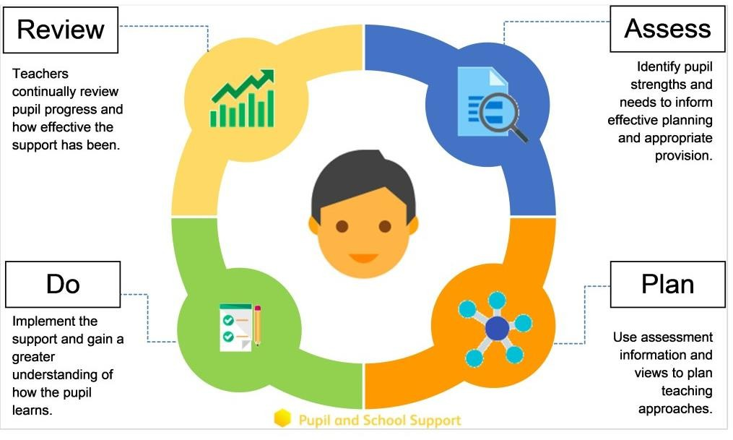  After a period of monitoring (one to two cycles of assess, plan, do, review), we will decide if a child needs to be placed on the SEND register and invite you in for a meeting, where we will share the support they are receiving and plan next steps.

 | Some children may require more support than is ordinarily available and we may ask outside agencies to support us in ensuring that we are offering the best support we can. Staff can access the ‘Ordinarily Available Guidance’ document produced by Essex Local Authority to help support children’s learning within the classroom.
Support for children with  SEND   | We are an inclusive school. Wherever possible children are taught alongside their peers in flexible teaching groups.  Teachers adapt their high-quality teaching to cater for their pupils’ needs and plan for them individually where necessary. When appropriate, staff are deployed to give children additional interventions in small groups outside the classroom, or to provide one-to-one support. We use the Endowment Education Foundation (EEF) guidance ‘Five-a-day’ and embed the key principles into all our lessons.  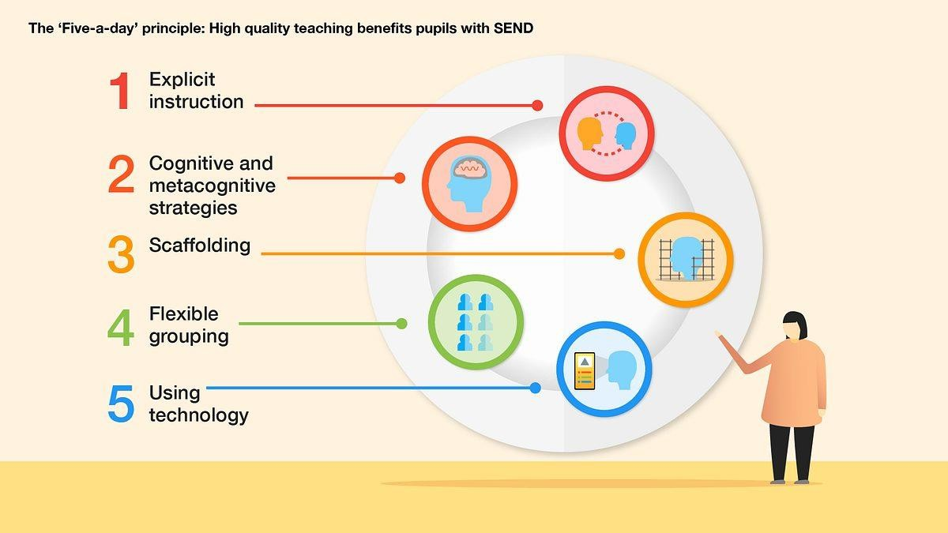  We also use a TPP approach alongside ordinarily available guidance.

Curriculum Adaptations   | We use a range of strategies across our lessons to ensure we offer an inclusive approach to learning and allow all children to access the classroom environment.  We also seek advice and equipment from outside agencies as and when the need arises.
 |  |  |  | 
 |  | Visual timetables | Task boards | Peer mentoring
 |  | 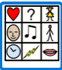 |  | 
 |  | Communication boards | Talk partners | Peer marking
 |  |  |  | 
 |  | Self- assessment | Word banks | Positive behaviour
 |  |  |  | 
 |  | Ear defenders | Timers | Explicit instruction

Securing School Resources   | It is possible that your child’s needs mean we need to secure:  - extra equipment or facilities  - more teaching assistant hours  - further training for our staff  - external specialist expertise  If that is the case, we will consult with external agencies to get  recommendations on what will best help your child access their learning.  The school will cover up to £6,000 of any necessary costs. If funding is needed beyond this, we will seek it from our local authority.
Inclusion in all aspects of school life   | All our extra-curricular activities and school visits are available to all our children, including our breakfast club (adaptions are made to facilitate this).  All children are encouraged to go on our trips, including our residentials, risk assessed and discussed with parents. In the case where a trip or residential cannot be safely risk assessed for a child adaptions to the trip and staffing are considered as well as alternative offers which equally enrich the child’s curriculum.  All children are encouraged to take part in sports day, school competitions, school assemblies and performances, workshops, etc.  All children are encouraged to apply for roles of responsibility in school e.g. school council, faith leaders, prefects etc.  No child is ever excluded from taking part in these activities because of their special educational need and/or disability.
Transition | We aim to make transition to the next class or school as easy as possible for all children.
Starting School   | - Meet with you and your child to talk about their needs and answer any questions you might have about our school  - Meet/talk with staff at your child’s previous school or setting  - Provide your child with a transition book with photographs of key staff and areas around our school, if necessary  - Read reports from people who have worked with your child  - Arrange visits to our school so your child gets to see it before they start properly  - Give any adult working with your child a one-page profile describing the things that help to support them in school.

Nursery to Reception | - We hold a parent and carer session in the summer term for our new reception starters, providing parents with the opportunity to meet with the class teacher and SENDCO.  - We hold a ‘taster’ session in the second half of the summer term in preparation for their September start and thereafter into each successive year-group, which is supported by meetings, information leaflets and taster sessions in each new class.
End of Year Transition | - When children move up a year, we provide transition sheets which include photos of the teacher/support staff and classroom environment.  - We hold transition sessions during the summer term allowing the children to go up to their new classroom and meet their teacher. Some children may require extra transition visits to their new classroom to help reduce their anxiety and ensure that the transition is successful and positive.  - Class teachers and support staff meet with each other during the summer term to discuss the needs of the children and share information about the things that help to support your child in school.  - We will talk to you and your child in the summer review meeting so we can answer any questions you may have.
Transition to Secondary School | - We liaise very closely with our partner schools to ensure that the transition from primary school to the secondary school is as smooth as possible.  - We may hold a review in some instances and invite key staff from the new school  - Talk to key staff at the new school about things that help your child to learn well and be happy at school  - Arrange extra visits to the new school with a member of staff from our school if necessary.
Mid-Year New Starters | - When we are aware that pupils joining us from other settings have identified special educational needs, we arrange a meeting with the family and the previous school to enable us to gain a greater understanding on the support we need to put in place.

Evaluating Provision   | Establishing children’s baseline before receiving interventions and reviewing the impact of interventions at regular intervals.  Reviewing children’ individual progress towards their goals at regular intervals, as a minimum every term.  Monitoring by the SENDCO/Leadership Team. Regularly using a tracking tool to update targets and measure progress.  Review progress in pupil progress meetings and discussing next steps.  Discuss and share ideas in staff meetings to ensure up to date research and policy is in place.  Holding termly & annual reviews for children who are on Education Health and Care Plans, SEND Support Provision Plans and those requiring  specialist support.  Asking our children if they feel the adjustment or intervention is helpful and makes a difference.  Feedback from Teachers, Teaching Assistants, SENDCO and any other professionals.  Feedback from parents.
Pupil Views   |     Pupil’s views are very important; they have a right to be involved in decisions about their education and they are made aware of the support that surrounds them in school. Children are fully involved and their views feed directly into all policies, procedures and daily teaching of children with SEND. Pupils are given regular opportunities to:  Attend meetings  Self-assess how and help decide Feedback and Review they are doing the support progress/interventions.  needed.

Parent  Consultation     | At St. Teresa’s Catholic Primary, we work closely with parents and carers and recognise that they have much to contribute to our support for children with SEND.  Our school has an open-door policy to parents/carers ensuring we are  always approachable. The SENDCO is available at parents’ evenings to discuss any concerns.  Parents' Evenings are held once a year. At February half term and the end of the school year you will receive a written report and you will be given the opportunity to discuss the report at a Parents' Consultation meetings.  For children who have an Education, Health and Care Plan, SEND Support Provision Plan or require specialist support (over and above what is ordinarily available) we will invite you in for 3 meetings a year in the Autumn, Spring and Summer term. These meeting are used to celebrate your child’s learning, looking at the progress they have made against the targets set, create new targets and discuss next steps.  Some children may have a home/school diary so information can be shared between home and school.  During the year a parental questionnaire is sent out to gain views on the school and the SEND provision. If a concern has been raised about your  child’s progress you will be invited into school to speak to your child’s Class Teacher. This is an opportunity for you to share relevant information about your child. You may also be invited to a meeting with Faye Gillings, our  SENDCo.

Support for Parents | As part of our open-door policy the class teacher is regularly available to discuss your child’s progress or any concerns you may have and to share information about what is working well at home and at school so similar strategies can be used.  Mrs Gillings, the SENDCO, is available to meet with you to discuss your child’s progress and any worries/concerns you may have.  All information from outside agencies will be shared with you.  Your child’s provision will be reviewed three times a year with your involvement.  A home/school book may be used to support communication with you in some instances.  We will signpost you to parent support groups.  National charities that offer information and support to families of children with SEN are:  - IPSEA  - SEND family support  - NSPCC  - Family Action  - Special Needs Jungle  If you have questions about SEN or are struggling to cope, please get in touch to let us know. We want to support you, your child and your family.

Staff Training   | At St. Teresa’s Primary, we believe in professional development and  aim to ensure all our staff have the understanding they need to enable them to support your child.  When a new member of staff joins the school, we ensure they understand the systems within school and they are given information about the children they are working with.  The senior leadership team within school are constantly moderating needs within the school and, where an area of concern is highlighted, whole school training may be organised to ensure all staff understand specific  learning difficulties and appropriate teaching or support strategies that could be utilised.  When staff go on a course, they have an opportunity to give feedback to the rest of the staff during staff meeting sessions. Some of our staff have completed training in the following areas.
 |  |  |  |  | 
 |  | Play Therapy | Lego Therapy | Child  Development | Bucket time
 |  |  |  | 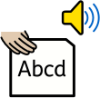 | 
 |  | Autism  (Level 1) | Workstations | Phonics  Little Wandle (SEND) | Team Teach
 |  |  |  |  | 
 |  | Specific Learning  Difficulties | Complex Needs training | Emotion Coaching | Speech and Language
 |  |  |  |  | 
 |  | De escalation | Attachment | Sensory Circuits | Sensory needs

Outside Agencies   | Where a child continues to make little or no progress, despite support that is matched to their need, the school will consider involving specialists,  including those from outside agencies. Referral to these agencies will  always be discussed with you and you may be asked for parental consent to complete a referral. Here are some of the main outside agencies who work with pupils and their families. Once the feedback has been received, we will share the advice.
Educational Psychology Service (EPS)   | Support for children with complex needs.  Our Educational Psychologist is Sophie Stone
Speech and  Language Therapy (SALT) | Support for children with speech and language difficulties.  Our NHS SALT representative is: Erena Charles  The Christus Catholic Trust also work with Clarity Independent Speech and Language Therapy Service. Home - Clarity Independent Speech and Language Therapy

Occupational  Therapy Service (OT)   | Support children to carry out activities they need, want, or are expected to do, but are prevented from doing due to impairments, injuries or developmental conditions.  Children's Occupational Therapy | NELFT NHS Foundation Trust
Sensory Support Service (SSS)   | Support children with a visual or hearing impairment.  Thurrock Sensory Service for Deaf Children and Families | Ask Thurrock  Thurrock Sensory Service for Children & Young People with Vision Impairment | Ask Thurrock  Physical and sensory needs | Essex Schools Infolink
Community Paediatric Service | Medical service for both pre-school and school age children and their families and carers.
Mental Health Support | The Southend, Essex and Thurrock Child and Adolescents Mental Health Service (SET CAMHS) provides advice and support to children, young people and families who are in need of support with their emotional wellbeing or mental health difficulties.  Southend, Essex and Thurrock (SET) CAMHS | NELFT NHS Foundation Trust  Our trust schools are also supported by Brentwood Catholic Children’s Society also.  https://www.bccs.org.uk/
School Nurse   | Support for children with medical needs.
 | As a school we make reasonable adjustments to ensure that all children are fully included. Typical adjustments include:  - the school building is accessible to children with a physical difficulty via ramps,  - a disabled toilet and changing facilities,  - extra-curricular activities are accessible to all children,  - purchase or hire of specialist equipment recommended by outside agencies,  - additional adult support where necessary.  Please read the school’s accessibility plan for further information about the steps we have taken to prevent disabled children from being treated less favorably than other children and the arrangements we have made to help children with special educational needs and disabilities access our school.

Looked after Children (LAC)   | Jac Bottjer (Headteacher) is the Designated Teacher for Looked After Children.  He works with all staff to make sure that they understand how a looked- after or previously looked-after pupil’s circumstances and their SEN might interact, and what the implications might be for their school life.  Children who are looked-after or previously looked-after will be supported in much the same way as any other child who has SEN. However, looked- after pupils will also have a Personal Education Plan (PEP).  We will make sure that the PEP and any SEN support plans or EHC plans are consistent and complement one another. The school works closely with  Virtual Schools in order to secure any extra support or funding that the child might need to enhance their school experience.
SEND Policy   | Our school’s Special Educational Needs and Disability (SEND) policy can be found in our Policies section on the school website:  www.st-teresasrc.essex.sch.uk
SEND Governor   | A member of our governing body has specific oversight of the school’s arrangements. A member of the governing body has specific oversight of the school’s arrangements for SEND. At the time of writing this is Stacey Cheshire.  A SEND report is shared with the governing body to ensure all governors are aware of how children with special educational needs and disabilities are being supported in the school and how well this support is working. This is within the termly headteacher’s report to governors and is co-authored by the head and SENCO  At the time of writing, Melita Benoy is the acting Chair of Governors.
Complaints   | Your first point of contact is your child’s class teacher. If you are not satisfied that your concern has been addressed, then you may make an appointment to speak to the SENDCO. If they cannot solve your issue, then an appointment can be made to speak to the Headteacher.  If you are not happy with the response, then you may contact the Governors through the school office (send the office an email explaining that you wish to be put in touch with a governor and they will give you their contact details.)  In the unusual event that your issue cannot be resolved successfully you will then be referred to the school’s complaints policy.
The SEND  Local Offer | A Local Offer gives children and young people in the borough, who have Special Educational Needs (SEN) and/or a disability, information in one place. The Local Offer aims to provide clear, comprehensive and accessible information about what services and provisions are available in the area for parents and young people.  The local offer is part of the reforms to support children and young people with SEND under the Children and Families Act 2014.  www.send.essex.gov.uk  SENDIASS stands for Special Educational Needs and Disabilities Information Advice and Support Service. It's a free, impartial, and confidential service offering information to young people with special educational needs and disabilities (SEND) and to their parents and carers.  www.essexsendiass.co.uk

Glossary

Access Arrangements | Special arrangements to allow pupils with SEN to access assessments or exams
Annual Review | an annual meeting to review the provision in a pupil’s EHC plan
Area of Need | the four areas of need a pupil with SEN can have. These are:  Communication and Interaction; Cognition and Learning; Physical and/or Sensory and Social, Emotional and Mental Health Need
Adaptations | when teachers adapt how they teach in response to a pupil’s needs
Co-production | the involvement of parents and professionals in the design and delivery of services. In primary schools, this involves parents working with  teachers to improve the educational development of their children.
EHC Needs Assessment | the needs assessment is the first step on the way to securing an EHC  plan. The local authority will do an assessment to decide whether a child needs an EHC plan
EHC plan | an Education, Health and Care (EHC) plan is a legally-binding  document provided by the local authority that sets out a child’s needs and appropriate provision be that within a mainstream school or more specialist provision
Graduated approach | an approach to providing SEN support in which the school provides support in successive cycles of assessing the pupil’s needs, planning the provision, implementing the plan and reviewing the impact of the  action on the pupil
Intervention | a short-term, targeted adaptation to teaching or SEMH support for a  child with a specific outcome in mind
Local offer | information provided by the local authority that explains what services  and support are on offer for pupils with SEN in the local area. School has no direct input regarding what the local authority is able to provide
Outcome | target for improvement for pupils with SEN. These targets do not  necessarily have to be related to academic attainment
Reasonable Adjustments | changes that the school can make to remove or reduce any  disadvantages caused by a child’s needs within the confines of a mainstream school
SENDCo | the Special Educational Needs and Disabilities Co-ordinator
SEN | special educational needs
SEND | special educational needs and disabilities
SEND Code of Practice | the statutory guidance that schools must follow to support children  with SEND
SEN Information  Report | a report that schools must publish on their website, that explains how  the school supports pupils with SEN
SEN Support | special educational provision that meets the needs of pupils with SEN
Transition | when a pupil moves between years, phases, schools or life stage

