
Welcome to St Teresa’s Little
Learners

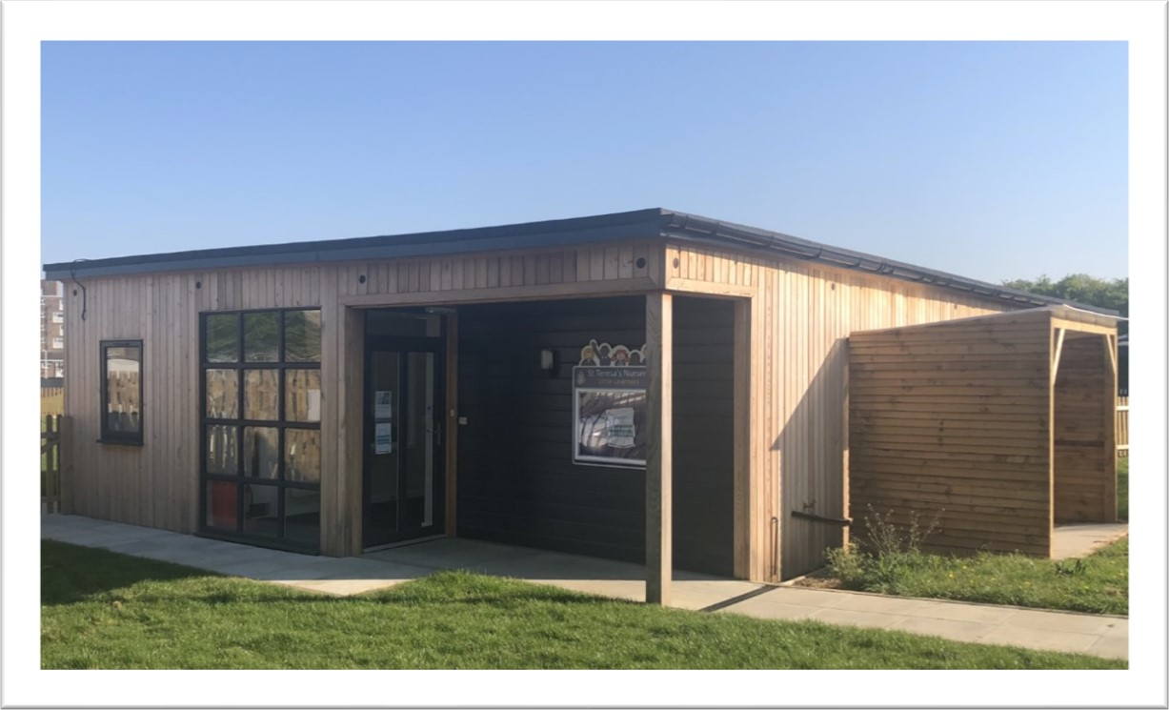

St Teresa’s Little Learners is part of St Teresa’s Catholic Primary School, we are a pre-school nursery provision serving the local community of Basildon.
Our purpose-built setting offers children rich and varied experiences to ignite their imagination, motivating them to explore, seek, discover and learn.

Our Nursery Team:

Mrs Gillings is the nursery manager and works alongside our nursery room lead Mrs O’Brien. We have two nursery support assistants, Miss Brown and Miss Golbourn.
Name | Role | Qualifications
Mrs. F. Gillings | Nursery Manager  SENCO  Head of Foundation stage | BA Hons in Primary Education, SENDCo, Paediatric 1st Aid.
Mrs. S. O’Brien | Nursery Room Lead | Level 3 Early Years, Paediatric 1st Aid.
Miss. J. Brown | Nursery assistant | Level 3 Early Years.  Paediatric 1st Aid.
Miss. H. Golbourn | Nursery assistant | Level 3 Early Years.  Paediatric 1st Aid.

Nursery Sessions (Term times only):
There are three types of attendance available at the nursery, we accept both 15 and 30 hour funding.
Morning Sessions (15 hours): 8.30am – 11.30am
Afternoon Sessions (15 hours): 12pm – 3pm
Full Day Session (30 hours): 8.30am – 3pm – Monday – Thursday plus Friday till 12.30pm, Children can stay all day Friday for the cost of £20 for the extra unfunded afternoon hours.

Admissions to Nursery:
You are welcome to apply at any time for admission to nursery. Please collect an application form from the main school office or email N@st-teresasrc.essex.sch.uk for an electronic copy, places are offered on a first come first serve basis.
We welcome visits to the nursery by appointment, please either contact the main school office and leave your name and contact details or email the nursery and the Manager will be in contact.
Children can start nursery the term after their 3rd birthday (funding eligibility dates are set out by Essex County Council):
3rd Birthday is between 1st April - 31st August – Start in the autumn term.
3rd Birthday is between 1st September - 31st December – Start in the Spring term.
3rd Birthday is between 1st January - 31st March – Start in the Summer term.

Our Curriculum – Learning through play
Between birth and 5 years old a child’s learning is more rapid than it will ever be in the rest of their life. For this reason, it is vital that children are given opportunities to develop solid foundations which to build their future learning. Skills such as communication, creativity, collaboration, curiosity and creativity, when promoted and developed in the early years are skills that will truly endure and underpin future success.
We follow the ‘Early Years Foundation Stage’ (EYFS), this is a curriculum framework that has been created by early years experts, professionals and parents. It sets out the expected milestones that children should achieve between birth and 5, typically children will be secure in the early learning goals by the end of their reception year. As an OFSTED registered setting we use this framework to plan, observe, assess and share your child’s progress.
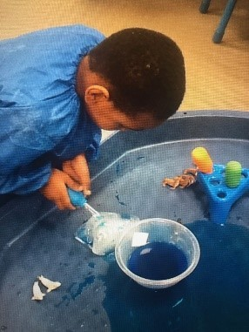
The EYFS sets out 7 areas of learning that guide our approach, 3 of these areas are called the ‘prime’ areas and the other 4 ‘specific’, the prime areas are those that run through all the other strands of work. Focusing on the children’s interests we offer a variety of adult lead and child-initiated activities throughout each day in order to develop new skills and knowledge. A combination of structured and free play allows children to explore their own ideas, practice what they have learnt and investigate their world, as well as being inspired and introduced to new concepts.

Parent partnerships
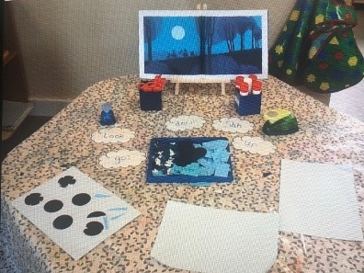
Parents are a child first and most influential educator, we understand the importance of building positive relationships with our families to support every child’s learning and development. We operate an open-door policy and parents/carers are welcome to talk to us daily. If a longer chat is required, you can make an appointment with the manager. Stay and play sessions, inspiration workshops and parent information evenings are held throughout the year and offer an opportunity for you to join in with nursery life, see first hand what your child gets up to at nursery and chat about your child’s learning, development and next steps. We use Tapestry, an online learning journal that allows parents and carers to view and contribute to their child’s learning and development record. These records are then passed onto your child’s reception teacher to give them the best start to their formal school journey.

Special Educational Needs and Disabilities
Any child attending the nursery with SEND is supported by all staff but more specifically our Pupil Support Manager and our SENCO (Special Educational Needs Coordinator), we are also able to call upon the support of our Speech, Language and Communication needs practitioner. The Nursery works closely with families and other professionals to provide a child centred approach to support and interventions.

Starting nursery
We appreciate that starting nursery can be daunting for both children and their parents. We have a supportive settling in process that enables you and your child to get to know the nursery setting and staff, as well as the opportunity for us to get to know your child to ensure a smooth transition into the setting. Upon confirmation of a place we will discuss settling in arrangements and provide you with a nursery handbook. If you have any questions about your child and the settling in process, please speak to the nursery manager.

Starting school
Children attending St Teresa’s Little Learners do not automatically transfer to the school’s reception class. You must apply through your local council: https://www.essex.gov.uk/topic/admissions.
If your child will be turning 5 years of age between 1st September and 31st August, then they will start school the September prior to their 5th birthday. Parents/ carers must make a school application through the local council’s website within the specified application window. Please ensure you know when the application window closes and submit your form with plenty of time.

If you have any questions, please feel free to get in touch:

S T T E R E S A ’ S L I T T L E L E A R N E R S
S T T E R E S A ' S C A T H O L I C P R I M A R Y S C H O O L , E L S E N H A M C R E S C E N T , B A S I L D O N ,
  - S 1 4 1 U E
  - E L : 0 1 2 6 8 5 5 3 5 0 2
E M A I L : N @ S T - T E R E S A S R C . E S S E X . S C H . U K



St_Teresas_Little_Learners

St Teresa’s Little Learners

